
INDUSTRY REPORT
Wholesale Trade in the US
Mar 2026

About

IBISWorld
IBISWorld specializes in industry research with coverage on thousands of global industries. Our comprehensive data and in-depth analysis help businesses of all types gain quick and actionable insights on industries around the world. Busy professionals can spend less time researching and preparing for meetings, and more time focused on making strategic business decisions.

Table Of Contents | Standard

1. About 4
Codes 4
Definition 4
Related Terms 4
What's Included 4
Companies 4
Related Industries 5
Additional Resources 5
2. At a Glance 6
Key Takeaways 6
Products and Services 7
Major Players 8
Key External Drivers 9
Industry Structure 9
SWOT 10
Executive Summary 10
3. Performance 12
Highlights 12
Key Takeaways 12
Performance Snapshot 13
Outlook 23
Life Cycle 26
4. Products and Markets 27
Key Takeaways 27
Products and Services 27
Major Markets 31
International Trade 34
5. Geographic Breakdown 35
Key Takeaways 35
Business Locations 36
6. Competitive Forces 42
Key Takeaways 42
Concentration 42
Barriers to Entry 44
Substitutes 45
Buyer & Supplier Power 47
7. Companies 49
Key Takeaways 49
Market Share 50
Companies 51
8. External Environment 59
Key Takeaways 59
External Drivers 59
Regulation & Policy 62
Assistance 64
9. Financial Benchmarks 66
Key Takeaways 66
Cost Structure 66
Key Ratios 70
10. Key Statistics 72
Industry Data 72

1. About
https://my.ibisworld.com/us/en/industry/42/about

Codes
NAICS 2017 - USA | 42
NAICS 2022 - USA | 42

Definition
The Wholesale Trade sector is an intermediary step in the supply chain process. Companies in the sector distribute goods from agriculture, mining, manufacturing and information industries to downstream markets, typically without any transformation.

Related Terms

WHOLESALE BYPASS
A popular trend within retail and manufacturing industries whereby producers supply goods directly to retailers, eliminating the middleman.

RADIO-FREQUENCY IDENTIFICATION (RFID)
A technology that tracks products from the time they leave the assembly line to the time they leave the store by releasing continuous signals from a chip.

ELECTRONIC DATA INTERCHANGE (EDI)
The transmission of electronic documents between businesses from one computer system to another.

What's Included
- Wholesale of durable goods (motor vehicles, furniture, computers and hardware)
- Wholesale of nondurable goods (drugs, apparel, groceries and beverages)
- Wholesale trade, agents, brokers and electronic markets

Companies
- Mckesson Corporation
- Cardinal Health, Inc.
- Amerisourcebergen Corp

Related Industries

Industries in the Same Sector
- Competitors:
  - Manufacturing in the US
  - Retail Trade in the US
- Complementors:
  - Healthcare & Social Assistance in the US
  - Accommodation & Food Services in the US

International Industries
- Petroleum Product Wholesaling in Australia
- Motor Vehicle Parts Wholesaling in the UK

Additional Resources
- National Association of Wholesaler-Distributors
- International Federation of Pharmaceutical Wholesalers Inc.
- International Foodservice Distributors Association

2. At a Glance
https://my.ibisworld.com/us/en/industry/42/at-a-glance
Revenue  $11.6tr  ’21-’26 ↑ 0.2 %  ’26-’31 ↑ 2.5 % | Employees  7m  ’21-’26 ↑ 1.8 %  ’26-’31 ↑ 2.2 % | Businesses  748k  ’21-’26 ↑ 2.3 %  ’26-’31 ↑ 1.9 %
Profit  $511.8bn  ’21-’26 ↓ 0.7 % | Profit Margin  4.4%  ’21-’26 ↓ 0.2 pp | Wages  $625.0bn  ’21-’26 ↑ 1.1 %  ’26-’31 ↑ 2.2 %

Key Takeaways

Performance
- The Wholesale Trade sector has successfully navigated volatility to expand. This growth has been fueled by consumer spending and a steady flow of goods. However, inflationary pressures have undercut wholesalers' profit margin.
- Tariffs imposed under the Trump administration have raised global duties, lifting selling prices but stoking inflation concerns that could weigh on economic growth. At the same time, Middle East hostilities are driving up commodity prices, threatening to further erode wholesale profitability.
- Wholesale revenue growth will remain solid as the expanding economy fuels spending on goods. However, potential disruptions loom because of volatile energy prices and trade tensions. Commodity-driven wholesalers face challenges from fluctuating energy costs, while trade uncertainties persist due to tariff-related uncertainties.

Products and Markets
- Nondurable goods comprise the largest share of distributed products. The segment features a diverse product range, from essential consumables like chemicals and drugs to everyday items like magazines and petroleum.
- Other wholesalers represent the sector's largest downstream customer. These intermediaries facilitate the efficient transfer of goods and play a crucial role in moving goods further along the supply chain.

Products and Services
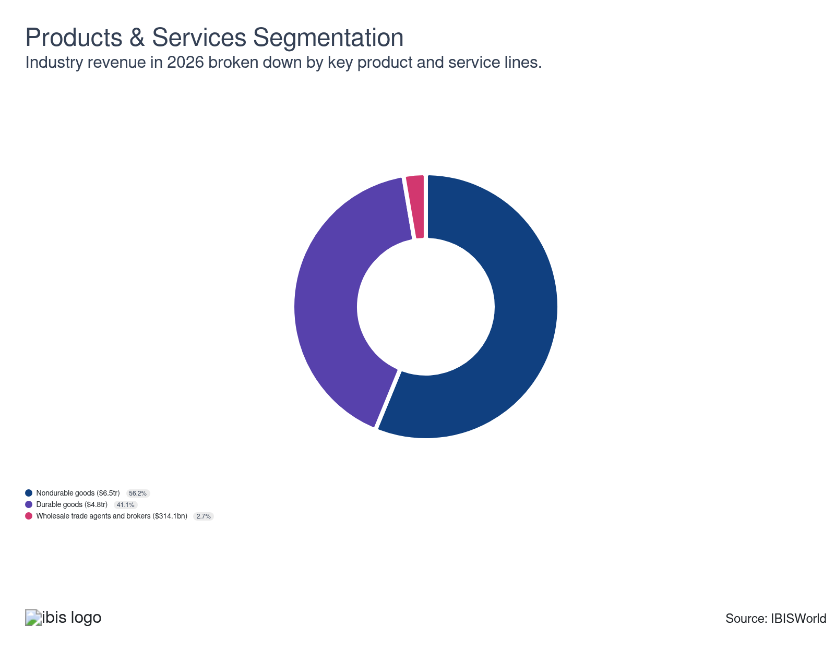

Major Players
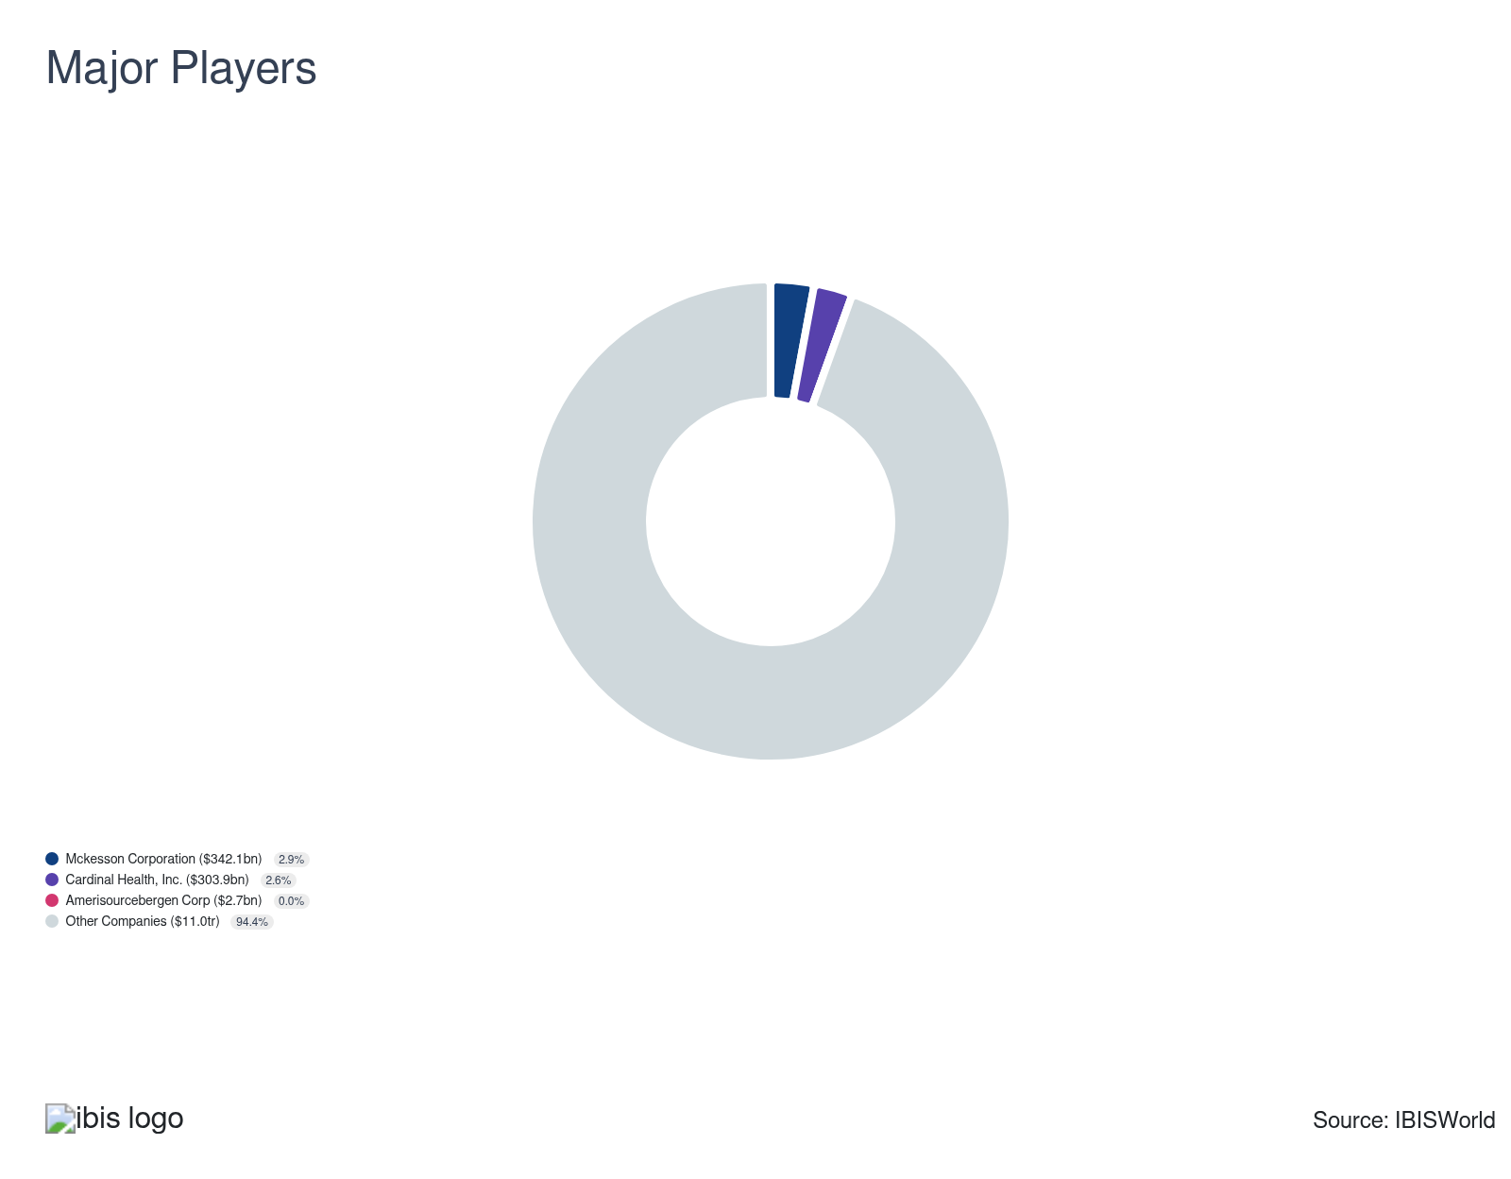

Key External Drivers
Key External Drivers | Impact
US Gross domestic product (GDP) | Positive
Total trade value | Positive
Consumer confidence index | Positive
Business sentiment index | Positive

Industry Structure
Characteristic | Level | Trend
Concentration | Low
Barriers To Entry | Low | Steady
Regulation and Policy | Low | Steady
Life Cycle | Mature
Revenue Volatility | Moderate
Assistance | Low | Steady
Competition | Moderate | Increasing
Innovation | Low

SWOT
Strengths  High Profit vs. Sector Average  Low Customer Class Concentration | Weaknesses  High Volatility  High Product/Service Concentration  Low Revenue per Employee  High Capital Requirements | Opportunities  High Revenue Growth (2021-2026)  High Revenue Growth (2026-2031)  High Performance Drivers  Total trade value | Threats  Low Revenue Growth (2005-2026)  Low Outlier Growth

Executive Summary

Equal distribution: Wholesale traders have relied on consumer spending to reach new heights
The Wholesale Trade sector has expanded, overcoming the volatility that has defined recent years. The sector has benefited from a rise in demand for goods from the Retail Trade sector (IBISWorld report 44-45) on account of greater consumer spending, driven by rising disposable income. The sector has also benefited from the steady flow of goods traded with the United States, necessitating their distribution. However, some of the sector’s growth has stemmed partly from higher selling prices for downstream products, driven by high inflation in the aftermath of the COVID-19 pandemic. Still, with US GDP rising faster than that of any other developed economy over the past five years, sector-wide revenue is forecast to grow at a CAGR of 0.2% to $11.6 trillion through the end of 2026.
Many industries that depend on commodity prices, especially those that move energy products down the supply chain, have been affected by price volatility. While the world price of crude oil collapsed as a result of a global economic slowdown in 2020 and the petroleum and petroleum products wholesale subsector experienced low prices, the world price of crude oil skyrocketed in 2021, contributing to 15.2% revenue growth across the sector. With global oil prices rising 39.2% in 2022 and inflation pushing prices upward, sector revenue increased 9.7% that same year. The Federal Reserve put the brakes on the economy to tamp down on inflation as a result, and rising interest rates coupled with tempering energy prices resulted in a sector-wide revenue contraction of 11.5% in 2023.
However, recent disruptions have introduced renewed volatility in commodity prices. In 2026, the start of conflict in Iran has quickly raised energy costs, as disruption from Middle East hostilities poses risks to crude oil, refined products, and natural gas trade flows worldwide. This comes despite substantial reductions in interest rates in 2024 and 2025 as inflation tempered, and despite the imposition of tariffs by the Trump administration, which has raised global duties to their highest levels in generations. In 2026, sector revenue is forecast to grow 1.5%.
Revenue will continue to grow as the economy expands, generating demand for goods to be moved along the supply chain by wholesalers. As a result, sector revenue will grow at a CAGR of 2.5% to $13.2 trillion through the end of 2030. However, the potential for disruption will remain, whether from volatile energy prices for commodity-driven wholesalers or from trade disruptions stemming from tariffs imposed by the Trump administration. The continued imposition of duties will raise prices for wholesalers, cutting into profitability, while their potential inflationary impact will make the Federal Reserve more cautious about easing interest rates, a hindrance to costly durable goods typically purchased on credit.

3. Performance
https://my.ibisworld.com/us/en/industry/42/performance

Highlights
Revenue  $11.6tr  2021-26 CAGR ↑ 0.2 %  2026-31 CAGR ↑ 2.5 % | Employees  7m  2021-26 CAGR ↑ 1.8 %  2026-31 CAGR ↑ 2.2 % | Businesses  748k  2021-26 CAGR ↑ 2.3 %  2026-31 CAGR ↑ 1.9 %
Profit  $511.8bn  2021-26 CAGR ↓ 0.7 % | Profit Margin  4.4%  2021-26 CAGR ↓ 0.2 pp

Key Takeaways
- The Wholesale Trade sector has successfully navigated volatility to expand. This growth has been fueled by consumer spending and a steady flow of goods. However, inflationary pressures have undercut wholesalers' profit margin.
- Tariffs imposed under the Trump administration have raised global duties, lifting selling prices but stoking inflation concerns that could weigh on economic growth. At the same time, Middle East hostilities are driving up commodity prices, threatening to further erode wholesale profitability.
- Wholesale revenue growth will remain solid as the expanding economy fuels spending on goods. However, potential disruptions loom because of volatile energy prices and trade tensions. Commodity-driven wholesalers face challenges from fluctuating energy costs, while trade uncertainties persist due to tariff-related uncertainties.

Performance Snapshot
Revenue: | ↑ 2021-26 Revenue CAGR +0.2%
Revenue  $11.6tr  ’21-’26 ↑ 0.2 %  ’26-’31 ↑ 2.5 % | 2026 Revenue Growth  ↑ 1.5 % | Revenue Volatility  Moderate
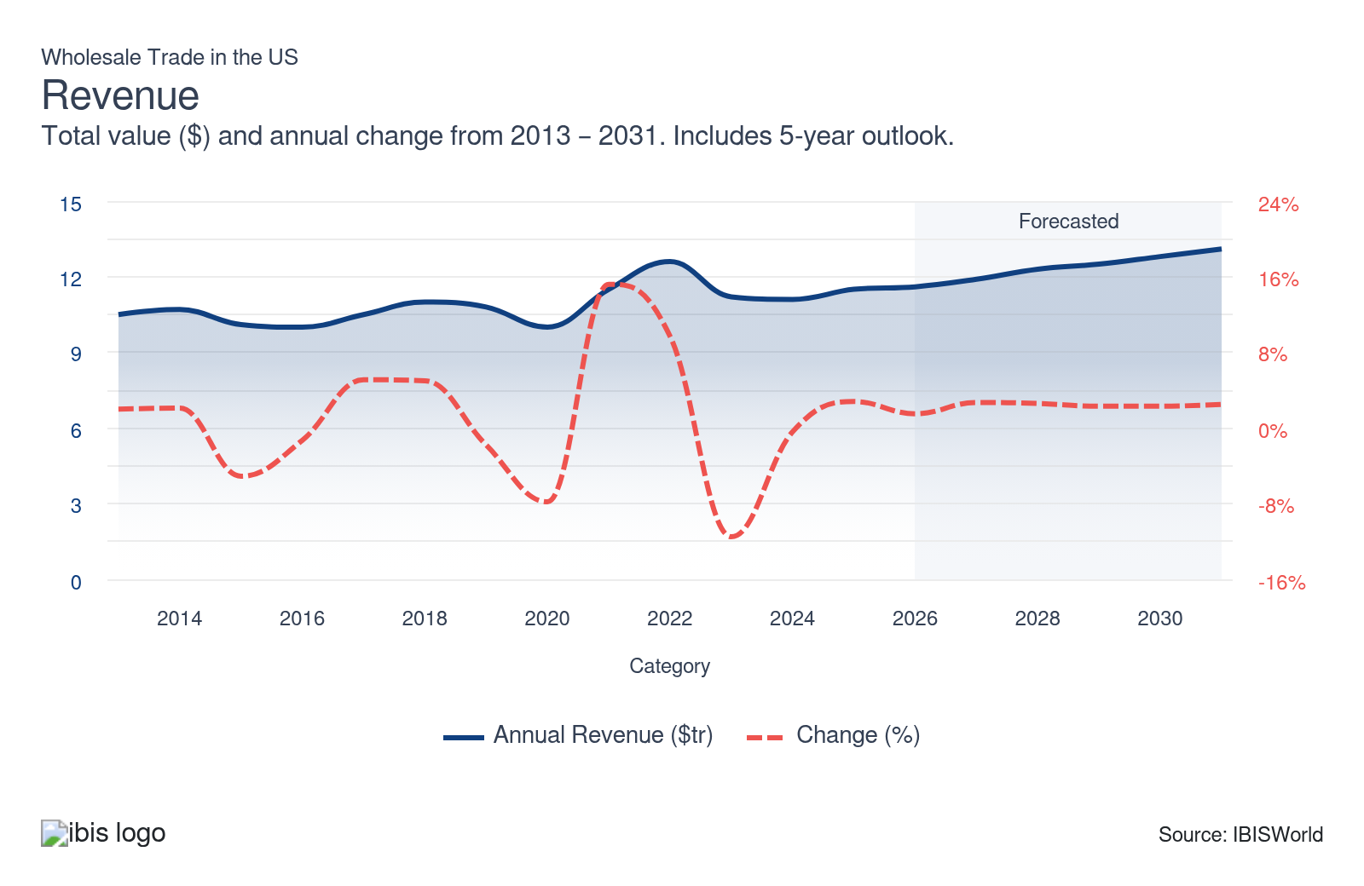
Employees: | ↑ 2021-26 Employees CAGR +1.8%
Employees  7m  ’21-’26 ↑ 1.8 %  ’26-’31 ↑ 2.2 % | Employees per Business  9  ’21-’26 ↓ 0.5 %  ’26-’31 ↑ 0.2 % | Revenue per Employee  $2m  ’21-’26 ↓ 1.6 %  ’26-’31 ↑ 0.3 %
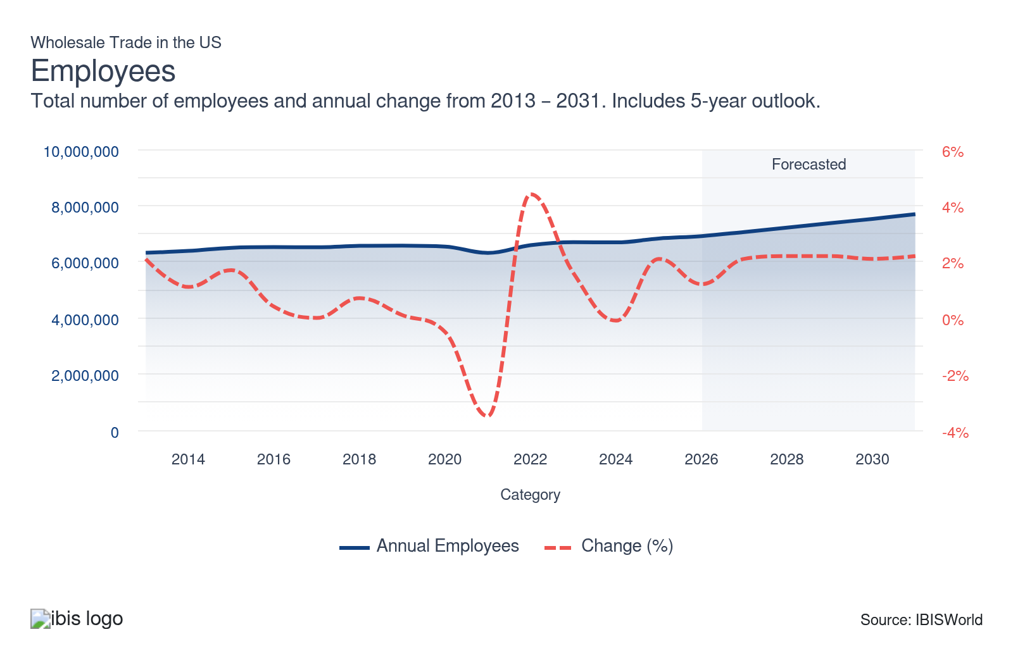
Businesses: | ↑ 2021-26 Business CAGR +2.3%
Businesses  748k  ’21-’26 ↑ 2.3 %  ’26-’31 ↑ 1.9 % | Employees per Business  9  ’21-’26 ↓ 0.5 %  ’26-’31 ↑ 0.2 % | Revenue per Business  $15.5m  ’21-’26 ↓ 2.1 %  ’26-’31 ↑ 0.6 %
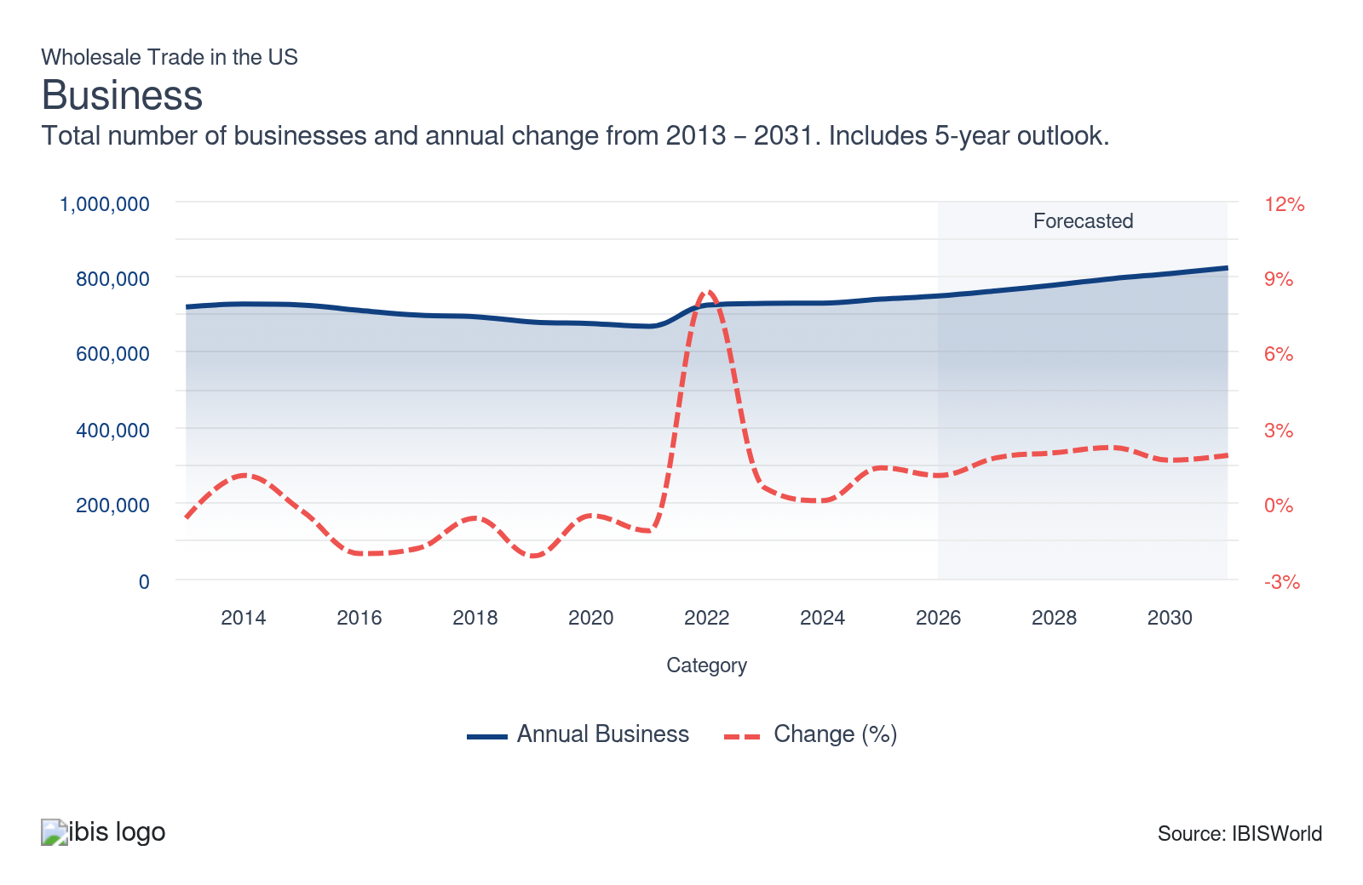
Profit: | ↓ 2021-26 Profit CAGR -0.7%
Total Profit  $511.8bn  ’21-’26 ↓ 0.7 % | Profit Margin  4.4%  ’21-’26 ↓ 0.2 pp | Profit per Business  $684.1k
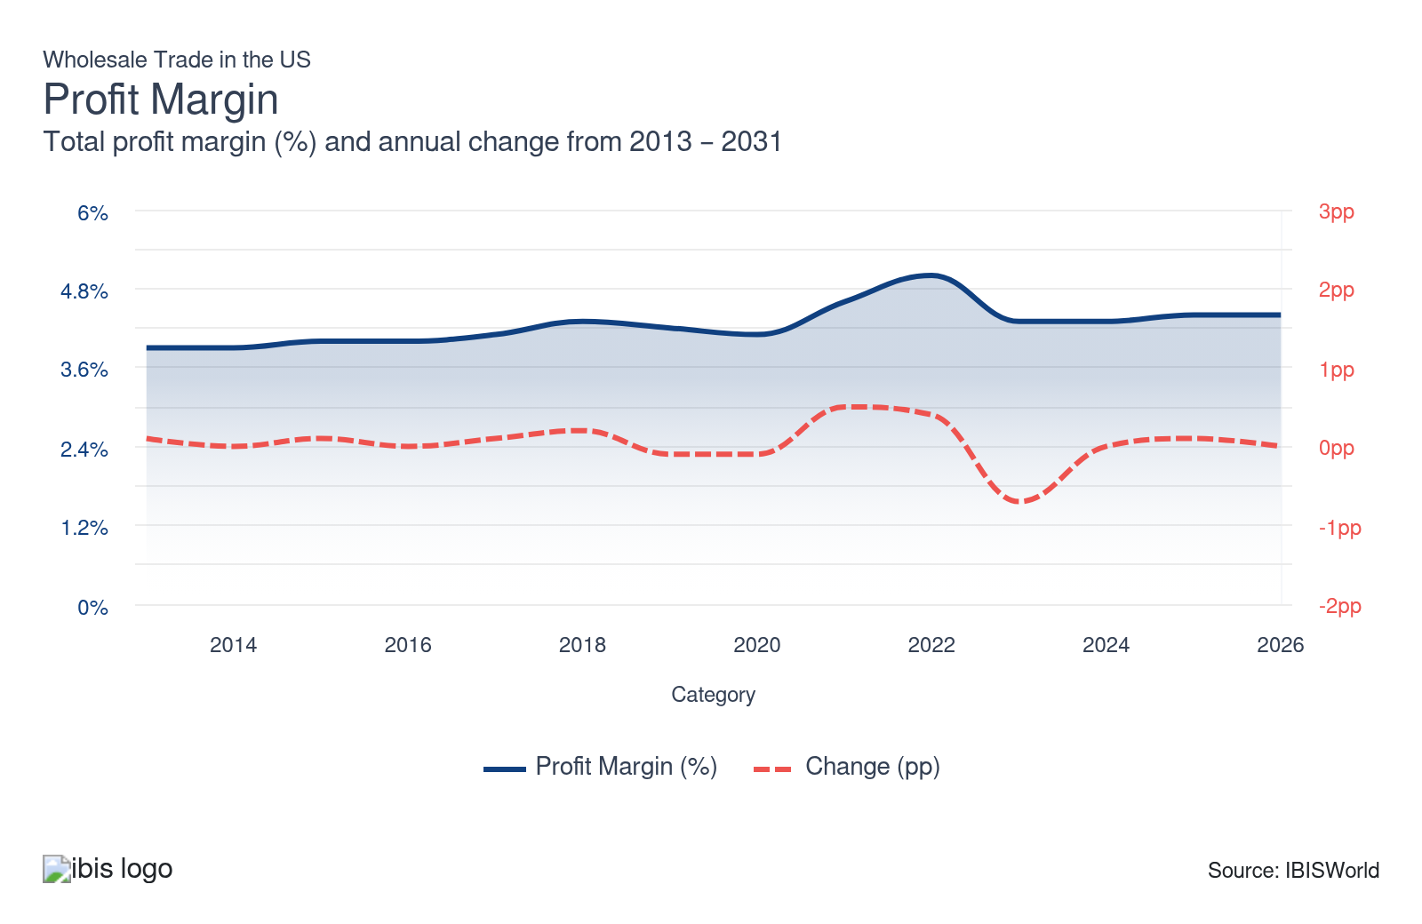
Current Performance
Current Performance

What's driving current industry performance?

The performance of the broader economy is reflected across the sector
- Demand for wholesale goods is determined primarily by the overall economy's performance, as wholesalers distribute goods to and from every sector of the economy. Consequently, the success of the Retail Trade (IBISWorld report 44-45), Manufacturing (IBISWorld report 31-33), Construction (IBISWorld report 23) and Healthcare and Social Assistance (IBISWorld report 62) sectors, among others, drive growth.
- The sector’s growth has been inflated since the COVID-19 pandemic triggered a dramatic economic downturn. Businesses were initially prevented from operating at full capacity, and global supply chains were snarled, leading to a drop in US GDP in 2020. The sector benefited from increased government support, which staved off a more significant downturn.
- To address the economic fallout, Congress passed the $2.2 trillion Coronavirus Aid, Relief and Economic Security Act in March 2020 and the $1.9 trillion American Recovery Act in March 2021. Government support helped thousands of companies across the United States stave off bankruptcy, with aid reaching three-quarters of all small businesses.
- The years since have seen the American economy grow steadily, far outpacing global growth. US GDP roared back as growth reached 5.8% in 2021, followed by 1.8% and 2.5% expansion in 2022 and 2023, respectively. In 2024, GDP growth for the year reached 2.7%, followed by 2.2% in 2025 according to advance Bureau of Econompyic Analysis estimates. The steady expansion of all sectors of the economy has undergirded the need for products distributed by wholesalers, with the fastest growth in the Retail Trade and Construction sectors.
- The wholesale sector’s growth has, in part, stemmed from higher selling prices for downstream products, driven by high inflation. The reopening of the economy following the pandemic was marred by global supply chain snarls and the Russo-Ukrainian War, among other challenges, which precipitated a once-in-a-generation bout of high inflation.
- The consumer price index (CPI), a measure of year-to-year inflation by the Bureau of Labor Statistics (BLS), rose at a CAGR of 4.4% from 2020 to 2025. Between 2021 and 2023, the CPI rose 4.7%, 8.0% and 4.1% in consecutive years. This resulted in higher prices across the economy, ultimately translating into higher wholesale selling prices, which contributed to some of the sector's revenue growth. However, this dampened profit margins across the sector, as many wholesalers were unable to adjust to price volatility and entirely pass on higher costs to downstream markets.

Wholesale trade thrives amid rising spending at the retail level
- Retail trade, the Wholesale Trade sector's largest direct market, has experienced fluctuations. Since demand from the sector depends on consumer conditions, rising incomes and high employment helped drive demand following the initial stage of the pandemic. The Consumer Confidence Index (CCI), calculated by The Conference Board, quickly returned to growth, rising 10.8% in 2021, enabling consumers to make more discretionary purchases.
- Strong consumer spending at the retail level has ultimately translated into strong demand for durable and nondurable wholesale goods. This surge in consumer spending has, in turn, increased revenue across retail trade, reflecting the robust market conditions.
- Similarly, demand for wholesale goods has been robust, though volatile, from many business users. The growing number of businesses has driven increased demand for a range of wholesale goods. The number of businesses in the United States, based on figures from US Census Bureau and County Business Patterns, is forecast to increase at a CAGR of 1.3% from 2021 to 2026 to reach more than 8.5 million during the current year. The period has seen the addition of more than half a million new enterprises in the US, driving upstream spending on goods sourced from wholesalers.
- The US Logistics Manager’s Index (LMI) reached 60.7 in June 2025, rising from 59.4 in May. This marked only the third time in over two years the index crossed 60.0, underlining continued strong supply chain activity in the first half of 2025. The LMI stood at 59.6 in January 2026, rising from 54.2 in December 2025 and marking the fastest rate of expansion since May 2025. Any reading above 50 indicates that logistics is expanding. The monthly LMI measures eight components within the logistics sector, including inventory levels and costs, warehousing capacity, utilization and prices and transportation capacity. This consistency is further evidence that the wholesale logistics has been expanding at a steady, sustainable pace.

Commodity prices have seesawed violently
- In contrast to the overall sector's growth, industries affected by commodity prices have experienced substantial challenges. Since wholesale industries generate revenue from the distribution of resources for further downstream use, they depend on the ultimate price of commodities. Most notably, recent years have been marked by crude oil prices' large swings.
- The world price of crude oil declined 32.0% in 2020 alone, hampering oil-dependent industries in the wholesale sector. Despite this, the crude oil prices increased 65.8% in 2021 and 39.2% in 2022, fueling sector revenue growth. In 2023, the crude oil prices fell once again, dropping 16.4%.
- Consequently, the Gasoline and Petroleum Bulk Stations industry (42471) and the Gasoline and Petroleum Wholesaling industry (42472) have experienced volatile revenue trends. Gasoline and petroleum bulk stations saw revenue decline 37.4% in 2020, rise 49.4% and 24.6% in 2021 and 2022, respectively. Likewise, gasoline and petroleum wholesaling experienced a revenue contraction of 28.7% in 2020, followed by growth of 8.9% in 2021 and 22.3% in 2022.
- The outbreak of conflict in the Middle East in 2026 has quicky pushed up crude oil, refined product, natural gas and shipping costs, which will likely translate into short-term revenue spikes but heightened volatility and margin risk for Gasoline and Petroleum Bulk Stations (42471) and Gasoline and Petroleum Wholesaling (42472), similar to the sharp swings they experienced in 2020–2022 when oil prices whipsawed.
- Moreover, disruptions in Strait of Hormuz flows and higher freight rates will likely raise supply uncertainty for these wholesale industries, meaning any top-line benefit from higher prices may be offset by tighter supply, increased working capital needs and greater exposure to sudden price corrections once the conflict eases.

Trump tariffs drive wholesalers to raise prices and rethink sourcing strategies
- In 2025, the Trump administration announced a sweeping set of import duties, including a baseline 10% tariff on all imports and sharply higher rates for specific trading partners. Shortly after implementation, the US made several adjustments, including temporary reductions in Chinese tariff rates and episodic suspensions, creating a volatile, unpredictable landscape for importers and wholesalers seeking long-term clarity.
- Wholesalers have responded to the wave of tariffs by rapidly importing goods ahead of each new tariff’s start date. Apple rushed products to market ahead of tariff hikes by pulling forward key iPhone shipments and accessories to US channels in early 2025. The company accelerated inventory movement before import duties on Chinese electronics reached 145.0%, while launching new India-made iPhones to counter price surges. This approach allowed wholesalers the ability to secure inventory at lower tariff rates, but storing the extra goods increased warehousing costs.
- Trump’s tariff policy has seesawed since 2025, with shifting rates, ad hoc exemptions and recurring threats against key trade partners. In February 2026, the Supreme Court struck down his use of emergency tariffs, but Trump has vowed to pivot to other legal authorities and could still raise tariffs further. Despite this volatility, overall tariffs remain well above pre-2025 levels, with the effective rate near the start of 2026 around 15% versus roughly 2–3% before Trump’s second term, according to estimates from the Congressional Budget Office and Yale Budget Lab.
- Repeated tariff rounds have kept pressure high between wholesalers and their suppliers, with wholesalers continuing to delay orders, push back on list-price increases and accelerate shifting volumes toward lower-tariff countries or domestic producers wherever contracts and supply chains allow. As a result, larger wholesalers have leaned more on multi-sourcing, shorter-term contracts and private-label strategies, while smaller firms with less bargaining power have often resorted to extra service fees, narrower assortments, or accepting thinner margins.
- Across categories such as electronics, groceries and apparel, the cumulative effect has been a steady drift toward higher shelf prices and more frequent price adjustments, as most wholesalers and downstream retailers cannot fully absorb sustained cost increases.

The wholesale landscape has faced challenges as they are bypassed
- The number of wholesalers active in the economy has contracted in recent years. The sector has faced substantial challenges, as many large retailers have sought to bypass the middleman and source goods directly from manufacturers. At the same time, online sellers can also sidestep wholesalers. These companies can also purchase goods directly from manufacturers, as well as from abroad, bringing them into consumer hands without relying on wholesalers in the United States.
- A surge in packages entering the US has been attributed to a trade provision championed by e-commerce giants Temu and Shein, allowing for duty-free entry with minimal scrutiny. This de minimis provision permits packages valued under $800 to enter the market via a streamlined process.
- Critics argue it creates a loophole that enables companies to circumvent tariffs and ignore bans on imports linked to forced labor. In fiscal year 2024 alone, at least 485 million packages have used this provision, according to The Wall Street Journal. Companies like Temu and Shein sidestep traditional examinations applied to bulk shipments by dispatching goods directly to consumers.
- However, tariff actions by the Trump administration have sharply changed trends for wholesalers and direct-to-consumer importers. The US ended its de minimis exemption for goods from China and Hong Kong on August 29, 2025, with all shipments from these regions now subject to full customs entry and import duties. This shift erodes the cost advantage for e-commerce sellers like Temu and Shein, who had relied on duty-free, small-package imports to bypass wholesalers.
- Still, companies are aggressively streamlining operations to stay competitive, focusing on reducing labor dependency. As part of this strategy, they’re also expanding through strategic acquisitions, snapping up smaller competitors to consolidate market share and diversify offerings.

What influences industry volatility?

Economic fluctuations impact the need for goods
- The Wholesale Trade sector dynamically drives merchandise distribution throughout the economy, covering products from agriculture, mining, manufacturing and specific information industries. As a key economic indicator, its performance actively mirrors broader economic trends, offering valuable insights into the overall economic health.
- Economic fluctuations significantly affect the volatility of the Wholesale Trade sector. Economic downturns often lead to reduced consumer spending, causing a ripple effect that depresses wholesale demand and increases market uncertainty. During economic upswings, wholesalers might face rapid shifts in demand that challenge their supply chain capabilities.
- This cyclical nature highlights the critical need for strategic planning and adaptability to successfully navigate shifting economic conditions. Businesses must demonstrate agility and foresight in managing inventory and responding to customer demands, ensuring they remain competitive and resilient amid changing economic landscapes.

Supply chain disruptions influence price changes
- Supply chain disruptions from natural disasters or geopolitical tensions significantly impact the wholesale sector, introducing volatility that can delay shipments, inflate costs and hamper the reliable delivery of products. Wholesalers should implement comprehensive risk management strategies and expand their supplier networks. to effectively manage these challenges.
- Diversifying suppliers buffers against supply chain interruptions and enhances operational resilience. By adopting this proactive approach, wholesalers can mitigate disruption impacts and maintain stable operations even during unforeseen events, thereby ensuring consistent product availability and preserving customer trust.
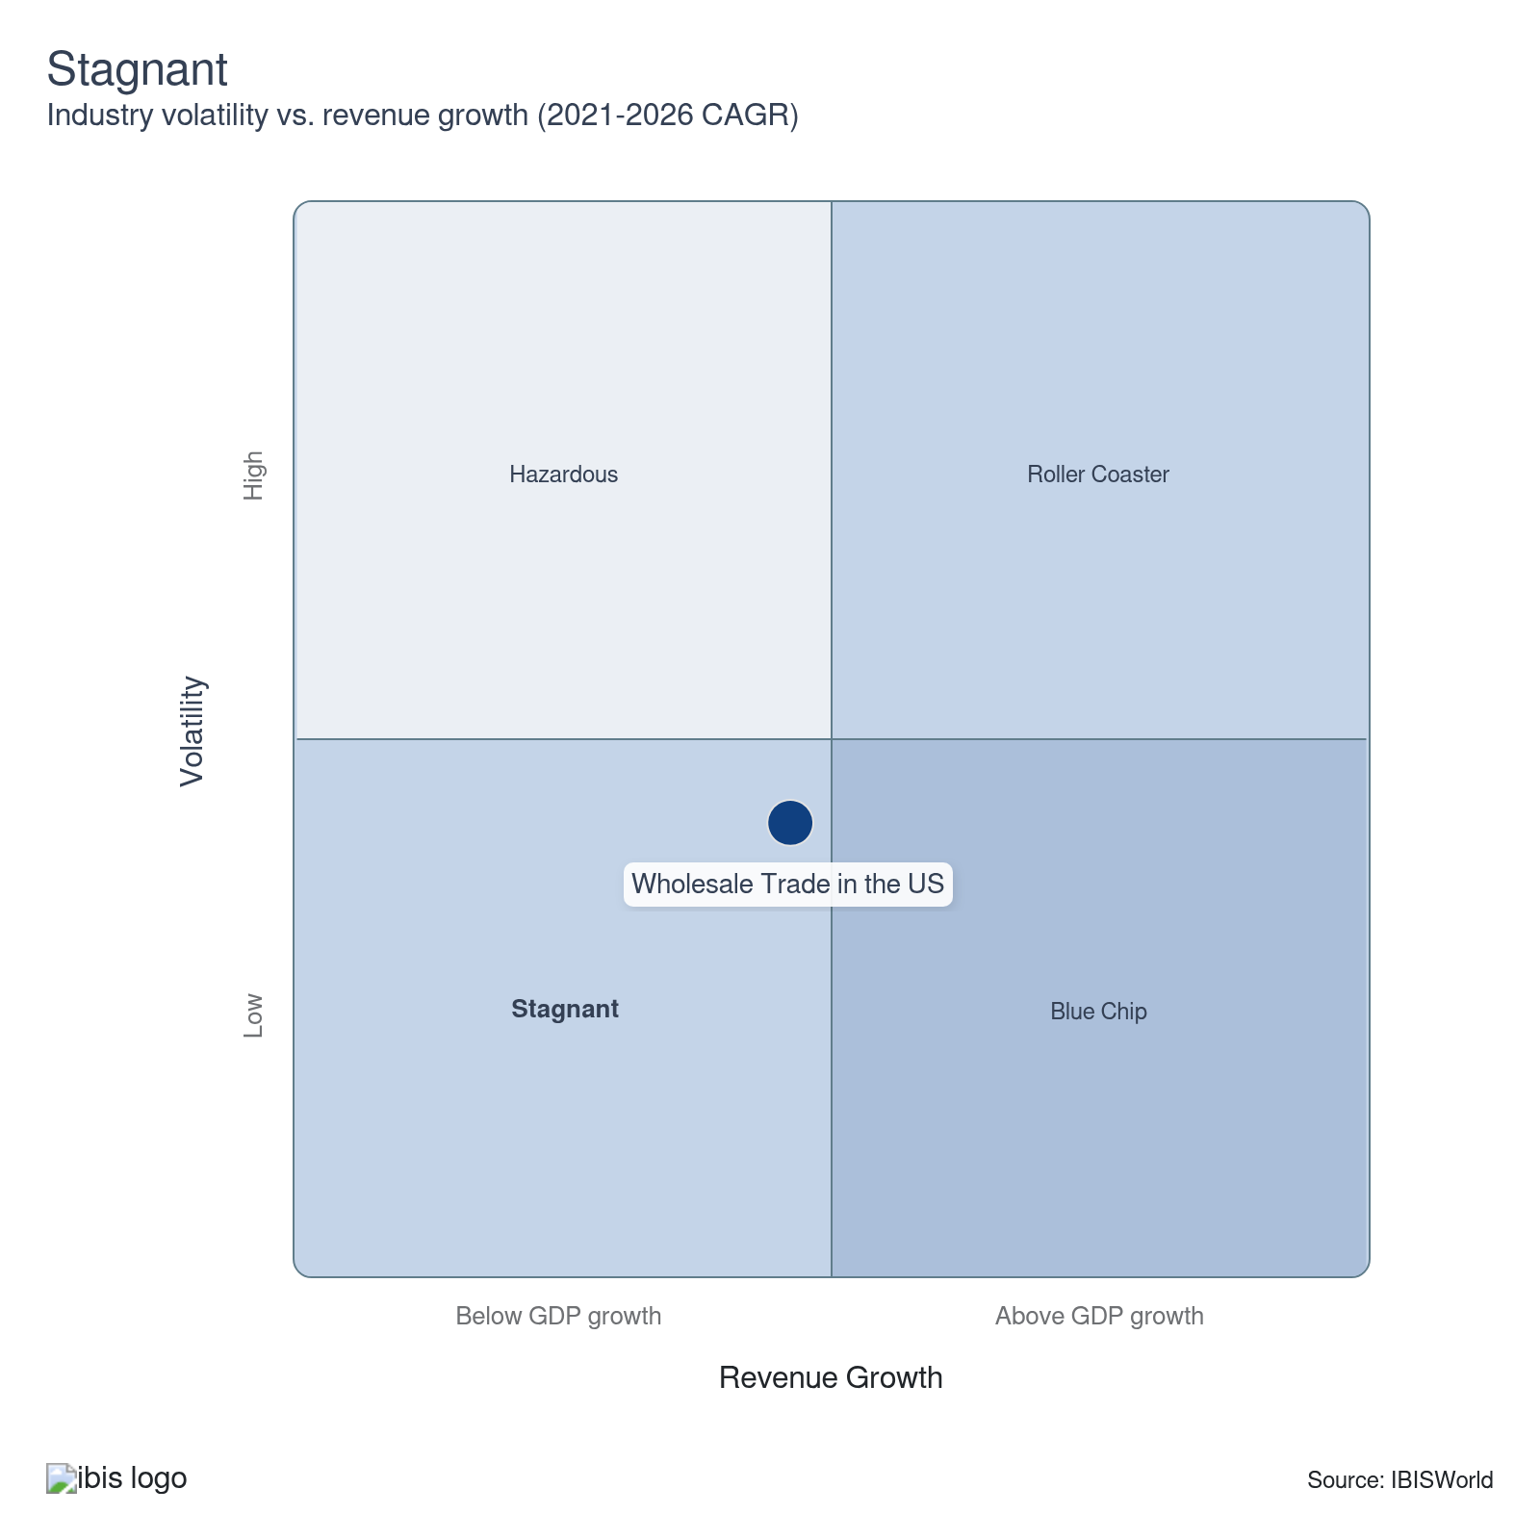

How do successful businesses overcome volatility?
Alter goods and services produced in favor of market conditions
Companies in wholesale trade tackle volatility by adapting product offerings to match current market conditions. Stocking high-demand items and maintaining high throughput keep warehousing costs low and prevent unsold inventory. This agility meets changing customer demands and ensures consistent sales.
Leverage product design, quality and brand strengths
By leveraging strong brand reputations, wholesalers maintain steady demand even during volatile periods. Those with highly differentiated products should pursue contracts to stock favored items, emphasizing design, quality and brand recognition. A reputable brand ensures reliability, stabilizes sales and provides a competitive edge.
Outlook | ↑ 2026-31 Revenue CAGR +2.5%

What's driving the industry outlook?

Wholesale trade will continue to reflect broader economic patterns
- Wholesalers distribute goods to and from every sector of the economy. Consequently, the success of the Retail Trade (IBISWorld report 44-45), Manufacturing (IBISWorld report 31-33), Construction (IBISWorld report23) and Healthcare and Social Assistance (IBISWorld report62) sectors will continue to drive growth.
- Nondurable goods will continue to comprise the majority of sector-wise revenue, including the sale of paper products, chemicals, drugs, textiles, apparel, footwear, groceries, farm products, petroleum, alcoholic beverages, books, magazines, newspapers, flowers, nursery stock and tobacco products. However, nondurable goods, which accounted for more than $9.0 trillion in wholesale revenue in 2026, will be subject to significant volatility as commodity prices fluctuate because of unforeseen geopolitical events like the outbreak of hostilities in Iran and the broader Middle East region.
- By contrast, the sale of durable goods, which are merchandise with longer shelf lives like motor vehicles, furniture, construction materials, machinery and equipment, metals, minerals, sporting goods, toys and hobby goods, will remain relatively stable as a share of revenue. As interest rates temper, the purchase of these goods on credit will increase.
- Finally, the sector's trade agents and brokers, which arrange sales and purchases for a fee, will see their share of revenue also contract as more businesses look to move these services in house. According to data from the Statistics of US Businesses from the US Census, the number of trade agents and brokers has declined by nearly 40.0% over the past decade and a half.

Consumer and business spending will rise, although the Federal Reserve gives pause to reigning in interest rates
- After several years of high inflation, price pressures have eased, with the Federal Reserve trimming rates in late 2024, pushing the federal funds rate down by 1 percentage point. In 2025, the Federal Reserve cut rates an additional three times, trimming borrowing costs for credit cards, home equity lines of credit and other debt, providing some respite to inflation-pinched consumers and businesses.
- At the start of 2026, the Fed has paused further cuts and signaled only limited easing ahead, keeping rates higher for longer as it watches inflation risks from Middle East–driven energy shocks and 2025 tariff hikes, which continue to push up costs in import-reliant sectors and complicate its path back to its target inflation rate. This will keep interest rates comparatively high longer than previously anticipated.
- Durable goods typically have a long lifespan and are often expensive, requiring large down payments, which can make them harder to finance. Thus, while a reduction in interest rates will help downstream purchasers afford these costly purchases, any about-face by the Federal Reserve could jeopardize the growth of durable goods sales.
- For example, Home Furnishing Wholesaling (IBISWorld report 42322), Heating & Air Conditioning Wholesaling (IBISWorld report 42373), and Refrigeration Equipment Wholesaling (IBISWorld report 42374) are anticipating increased demand from new construction undertaken by the Construction sector (IBISWorld report 23). In addition to the cost of financing purchases like new furniture and refrigerators, interest rates will play a pivotal role in the cost of building new houses.
- Even so, US GDP is forecast to grow, which will contribute to greater demand for goods. The overall labor market is forecast to remain strong over the next five years, amid tight labor conditions. The strong wage uptick will boost consumer disposable income, driving greater demand from the retail sector for both durable and nondurable goods.

While trade will remain big business, Trump tariffs will force wholesalers to overhaul pricing strategies
- Wholesalers are also expected to see growth as a result of a strong uptick in international trade. The total trade value, which measures import and export flows, is forecast to grow at a CAGR of 2.8% to $7.3 trillion in 2031, indicating strong trade flows with the United States.
- However, the Trump Administration's tariffs have imposed import duties on goods from most countries worldwide, including higher rates on specific goods, such as steel and aluminum. The end of the de minimis exemption means almost all imports, even small shipments, are now taxed. The direct cost for employers across retail and wholesale could reach $82.3 billion in 2025 alone, according to the Budget Lab at Yale, making these sectors especially vulnerable.
- Higher tariffs and the removal of de minimis status will continue to disrupt trade flows. Wholesalers importing high volumes of previously exempt, low-value goods, like electronics, apparel and home goods, now face increased customs costs, tighter cashflow and administrative complexity. Many are forced to pay duties upfront, eroding their working capital and raising their break-even point.
- While tariff costs will continue to raise prices for wholesalers, they will ultimately come out of consumers’ pockets through higher prices that may reduce trade volumes. As consumer prices rise, demand generally decreases, which could reduce trade volumes in the coming years.
- Wholesalers will have to balance these increased prices with maintaining their customer base, potentially undermining consumer trust and eroding profit profit in the long run as buyers seek alternatives. Analysis by the JPMorgan Chase Institute shows that distributors may absorb costs through lower margins, layoffs, or reduced hiring. Meanwhile, Goldman Sachs economists predict that wholesalers and retailers will only be able to pass on about 70% of tariff costs to consumers, with the rest cutting into profitability.

Commodity prices will remain subject to unexpected volatility as Middle East conflict looms
- Volatility in global commodity prices is unpredictable and is subject to immense instability. The Russia-Ukraine conflict has threatened energy stability since its outbreak in February 2022, as Russia is a major global oil producer. Most notably, the Israel-Hamas conflict has drawn other regional countries into the conflict, creating the potential for rising energy prices.
- Volatility is now likely to intensify as the latest Middle East hostilities lift energy costs further, as disruption risks grow for crude oil, refined products and natural gas trade flows worldwide. In the days following the start of military operations in Iran in February 2026, benchmark crude prices surged, with Brent crude jumping between about 7% and 10% to trade in the high-70s to low-80s per barrel. Missile and drone strikes across the wider region have raised the risk that traffic through the Strait of Hormuz, which normally carries around 20% of global oil flows, could be severely disrupted or temporarily halted.
- While the rise in energy prices and the cost of other commodities will increase aggregate revenue from sales to downstream consumers, this will negatively impact wholesalers’ profitability. For wholesalers that move energy products like oil downstream, shifts in oil, petroleum and gas prices are difficult to pass on because they have low market power.
- As a result, rising crude oil prices typically cut into the profit of companies in industries like Gasoline & Petroleum Bulk Stations (IBISWorld report 42471) and Gasoline & Petroleum Wholesaling (IBISWorld report 42472). The tempering of energy prices will thus bear fruit for wholesalers’ bottom lines.
- The Trump Administration has also promised to unleash already booming energy production in the United States, declaring a national energy emergency, reversing fuel economy standards, rolling back restrictions on drilling in Alaska and undoing a pause on gas exports. However, industry executives remain tepid on whether record production numbers will continue to rise, indicating that prices would have to increase for production to expand further.

Small- and medium-sized wholesalers look to opportunities in trade in fragmented sector
- The differentiation level determines the dominance an individual company can exert across an industry in the sector. In most industries, wholesalers have few opportunities to differentiate themselves. In the Corn, Wheat & Soybean Wholesaling industry (IBISWorld report 42451), wholesalers face limited opportunities for differentiation due to the homogeneity of products like wheat, corn and soybeans.
- Many of the sector's small- and medium-sized wholesalers will seek to expand their operations, as indicated by rising revenue per employee and per establishment figures across the sector. In doing so, small- and medium-sized wholesalers will be better able to invest in costly technologies that automate inventory control and reduce their reliance on labor.
- Small- and medium-sized wholesalers will find additional opportunities in trade. According to a May 2024 report by McKinsey Global Institute, small- and medium-sized wholesalers actively participate in cross-border activities, driven by commodity brokering in wholesale trade. This has translated to a 70% share for small- and medium-sized wholesalers in all trade exports.
- Still, most wholesalers will remain small. The average wholesaler is small, employing between 9 and 10 people, with an average of only 8 people per location. While more companies have sought to cut wholesalers out of the supply chain to reduce prices, wholesalers will remain essential to the movement of goods. The strong uptick in downstream retail industries, along with growth in trade, will benefit the sector.
Life Cycle | Mature

Why is the industry mature?

Contribution to GDP
The Wholesale sector is expanding faster than the overall economy, as inflation and rising commodity prices have pushed up selling prices. Unlike rapid expansion phases, wholesale trade focuses on incremental efficiency improvements rather than quick market gains.

Market Saturation
The sector features extensive market penetration, with well-established companies capturing significant market share. The presence of numerous players and a high level of market penetration limit growth opportunities. With most potential customer bases already reached, businesses focus on retaining existing clients and exploring niche markets to maintain profitability and sustain operations.

Innovation
Innovation primarily centers around improving efficiency rather than groundbreaking changes. To sustain growth, companies innovate within established frameworks, emphasizing technology integration, logistics optimization and customer relationship management rather than fundamentally disruptive industry changes. Wholesalers adopt automation to streamline processes, reflecting a shift from growth-focused innovation to sustaining competitive advantage in a saturated market.

Consolidation
The sector represents a broad swath of the economy, with no single company dominating. However, individual industries offering highly differentiated goods tend to have higher concentration levels. As a result, fewer but larger entities dominate, reshaping the competitive landscape while maintaining industry stability.

Technology & Systems
While technology has enabled industries across the sector to reduce their reliance on labor by automating supply chains, many companies have long adopted these technologies. Digital platforms, data analytics and integrated supply chain systems have optimized operations, reduced costs and improved customer service. This technological integration reflects a strategic focus on efficiency rather than expansion.

4. Products and Markets
https://my.ibisworld.com/us/en/industry/42/products-and-markets
Largest Market  $6.5tr  Nondurable goods | Product Innovation  Low

Key Takeaways
- Nondurable goods comprise the largest share of distributed products. The segment features a diverse product range, from essential consumables like chemicals and drugs to everyday items like magazines and petroleum.
- Other wholesalers represent the sector's largest downstream customer. These intermediaries facilitate the efficient transfer of goods and play a crucial role in moving goods further along the supply chain.

Products and Services
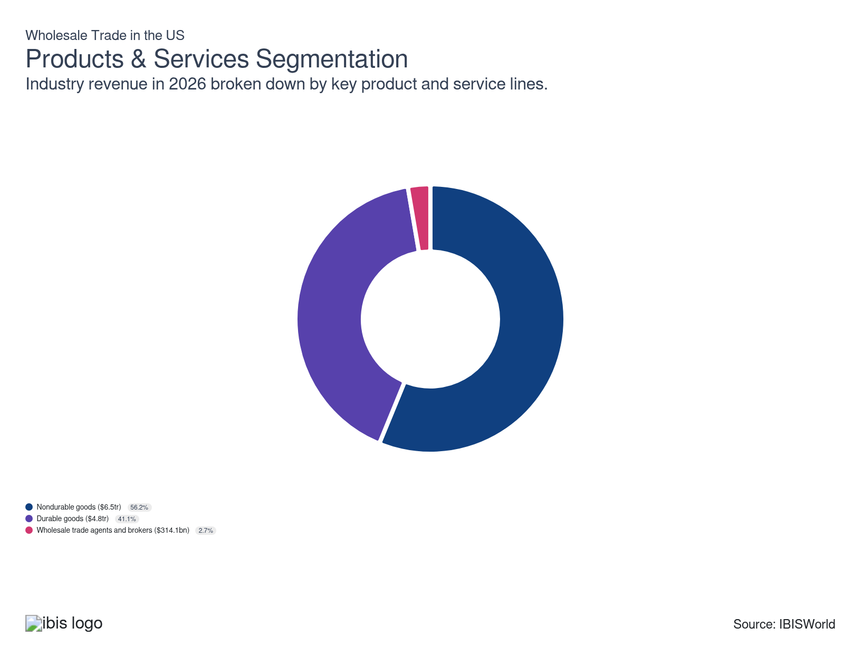

How are the industry’s products and services performing?

Volatile energy prices have impacted nondurable goods trade
- Nondurable goods are goods that are expected to last less than three years. The nondurable goods segment distributes paper and paper products, chemicals and chemical products, drugs, textiles and textile products, apparel, footwear, groceries, farm products, petroleum and petroleum products, alcoholic beverages, books, magazines, newspapers, flowers, nursery stock and tobacco products.
- Within this segment, revenue for the Drug, Cosmetic and Toiletry Wholesaling industry (IBISWorld report 42421) has been driven by rising insurance rates under the Patient Protection and Affordable Care Act (PPACA) and strong demand for less expensive generic medications.
- In contrast, the Gasoline and Petroleum Bulk Stations industry (42471) and the Gasoline and Petroleum Wholesaling industry (42472) have encountered significant volatility due to fluctuations in the global price of crude oil. These price swings have directly impacted operational stability, making strategic planning more challenging for businesses within these industries.
- Volatile commodity prices have significantly impacted the durable goods wholesale market. Durable goods accounted for 52.0% of revenue in 2021, as commodity prices spiked in the aftermath of the pandemic. Although these figures declined in later years, they are expected to spike once more in 2026 with the outbreak of conflict in the Middle East. Their share is forecasted to increase to 56.2% by 2026.

Revenue from durable goods has been dragged down by underperforming industries
- Durable goods are new and used merchandise like motor vehicles, furniture, construction materials, machinery and equipment, metals, minerals, sporting goods, toys and hobby goods. These items typically have a long lifespan and are used over an extended period.
- Industries affected by commodity prices have experienced volatile revenue, such as Metal Wholesaling (42351) and Coal and Ore Wholesaling (42352). Likewise, several industries within this segment have endured increasing price competition and a shift toward direct sales models. The Computer and Packaged Software Wholesaling industry (42343) is indicative of this trend.
- The decline in sales across some industries in this segment has been balanced by strong performance in others. Most notably, revenue for the Automobile Wholesaling industry (42311), Auto Parts Wholesaling industry (42312), Tire Wholesaling industry (42313) and Used Car Parts Wholesaling industry (42314) have all grown.
- The durable goods wholesale market is projected to exceed $4.8 trillion in 2026. However, its share of the wholesale market has contracted. Whereas durable goods trade accounted for 44.1% of sector revenue in 2021, this figure is forecast to drop to 41.1% in 2026.

Wholesale trade agents and brokers generate little revenue
- Wholesale trade agents and brokers act on behalf of buyers and sellers to distribute goods at a wholesale level. They refrain from taking the title of goods in the selling process, and instead, generate income from commissions and fees for their services. This segment comprises the Wholesale Trade Agents and Brokers industry (42512).
- Wholesale trade agents and brokers are seeing declining revenue because of the rise of large retailers with their own distribution networks, the increasing adoption of e-commerce, which allows direct business-to-business transactions and the overall diminishing need for traditional intermediaries in the market.

What are innovations in industry products and services?

Digital platforms for B2B transactions
- Wholesalers are increasingly adopting digital platforms to streamline B2B transactions, enhancing efficiency and accessibility. These platforms facilitate seamless order processing and inventory management, enabling real-time communication that optimizes procurement for all stakeholders.
- By leveraging data analytics through digital platforms, wholesalers gain critical insights into customer preferences and market trends. This enables them to offer personalized services and anticipate demand shifts, ultimately improving customer satisfaction and competitive advantage.

Automation in supply chain management
- Automation is revolutionizing the wholesale trade sector by dramatically enhancing operational efficiency. Advanced technologies such as robotics and artificial intelligence optimize logistics operations, reduce errors and expedite order fulfillment, increasing productivity across the entire industry.
- Automated systems equip wholesalers with powerful tracking and reporting tools, enabling them to monitor the supply chain in real time. This enhanced visibility enables businesses to proactively manage disruptions, maintain optimal inventory levels and ensure timely deliveries. With real-time insights, wholesalers can swiftly identify and address potential bottlenecks or inefficiencies, resulting in smoother operations.

What products or services do successful businesses offer?
Having contacts within key markets
Companies in wholesale trade leverage their network connections to penetrate critical markets effectively. Establishing strong relationships ensures consistent demand and smooth distribution channels, boosting their market presence and profitability.
Leverage economies of scope
By leveraging economies of scope, wholesalers can diversify and expand their product lines without incurring significant additional costs. This strategy broadens their market reach and enhances customer offerings, contributing to overall business growth.

Major Markets
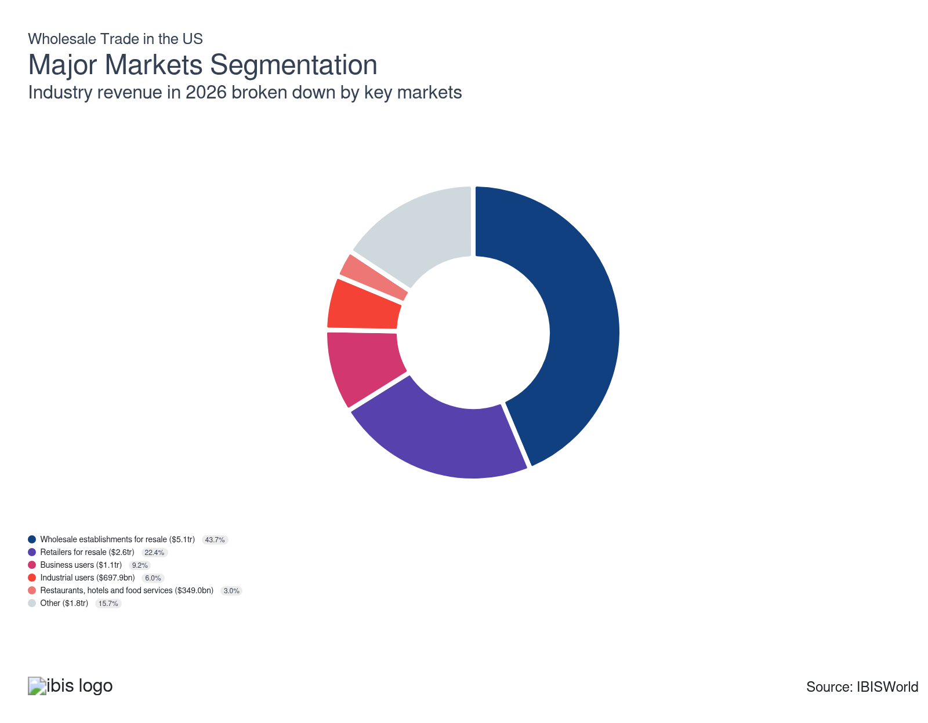

What’s influencing demand from the industry’s markets?

Most wholesalers resell products to other wholesalers
- Individual wholesalers buy goods from larger wholesalers and resell them to other businesses. This process helps distribute products more efficiently and tap into local markets. These wholesalers play a critical role in the supply chain by bridging the gap between large suppliers and smaller retailers.
- For instance, in the food sector, distributors in the Grocery Wholesaling industry (IBISWorld report 42441) purchase merchandise from other entities and resell it in their market. By acting as intermediaries, these distributors enhance market reach and ensure a steady supply of products to meet consumer demand.
- Wholesalers are increasingly engaging in transactions with other wholesalers, driven by the growing complexity of supply chains. As larger wholesalers acquire smaller ones, there's a heightened necessity to distribute goods across an expanded network. This often involves selling to other wholesalers who specialize in specific regions or customer segments. Whereas revenue from sales to wholesale establishments for resale accounted for 39.2% of revenue in 2021, this figure is projected to grow to 43.7% in 2026.

Retailers move goods down the supply chain
- Retailers buy goods and resell them in their stores to consumers. Retailers serve as the final link in the supply chain, ensuring that products from manufacturers or wholesalers reach the end-users. Their main goal is to provide a seamless shopping experience and meet consumer needs effectively.
- For example, in the Stone, Concrete and Clay Wholesaling industry (42332), materials are sold to downstream retailers for purchase. Companies have expanded local distribution centers in recent years to meet growing demand from both contractors and DIY consumers looking for reliable building supplies.
- Sales from wholesalers to retailers have declined because of the rise of manufacturers' direct-to-consumer strategies and the growing influence of online marketplaces like Amazon. Manufacturers are increasingly bypassing traditional wholesale channels to reach consumers directly, offering lower prices and personalized experiences. Meanwhile, platforms like Amazon provide retailers with easy access to a wide variety of products without the need for intermediary wholesalers.

Business users have diverse needs
- Businesses in this segment acquire various goods from wholesalers, including computers, peripherals, software and other office and business equipment. This enables them to equip their operations with the necessary tools and technologies. By sourcing from wholesalers, they can benefit from bulk purchasing and ensure they have the latest products.
- For example, in the Laboratory Supply Wholesaling industry (42349), distributors sell laboratory equipment, chemicals and supplies to private laboratories, research centers and educational institutions. They help ensure scientists and technicians have everything they need for experiments, product testing and quality control because of the growing need for advanced lab technologies.
- Sales from wholesalers directly to businesses are on the rise, largely driven by the growth of e-commerce platforms that allow for easier direct interaction between wholesalers and businesses, eliminating the need for intermediaries in many cases.

Industrial users purchase inputs into the production process
- The industrial market comprises manufacturing and mining companies that buy new and used machinery and equipment. These businesses invest in robust, reliable tools to enhance their production capabilities and operational efficiency. By focusing on high-quality machinery, they aim to increase output, reduce downtime and optimize overall performance.
- Companies rely on this machinery for their production and extraction activities, as it plays a crucial role in executing essential processes. By using advanced equipment, businesses can significantly increase efficiency and maintain high output levels.
- Industrial users have reduced their purchases from wholesalers, reflecting shifts in procurement strategies. This trend has been driven by several factors, including the growing ability of these companies to source materials directly from manufacturers, which has led to cost savings. Whereas revenue from industrial users accounted for 7.1% of revenue in 2021, this figure is projected to fall to 6.0% in 2026.

Restaurants, hotels and food services purchase in bulk
- The restaurants, hotels and food services segment includes industries like Hotels and Motels (72111), Single Location Full-Service Restaurants (72211b) and Coffee and Snack Shops (72221b). Because of their operational needs, these businesses often purchase merchandise in bulk from wholesalers at competitive prices.
- For example, in the Restaurant and Hotel Equipment Wholesaling industry (42344), distributors sell display cases, electrical signs, store fixtures, commercial shelving, showcases, soda fountains and vending machines to companies in the food service and accommodation business.
- Restaurants, hotels and food service establishments also purchase fewer goods from wholesalers, influenced by changing market dynamics. Many of these businesses are turning to direct purchasing from producers and local suppliers to secure fresher ingredients. The rise of digital platforms and online marketplaces has enabled them to efficiently source products directly, bypassing traditional wholesale channels.

Other segments of the economy
- This segment consists of builders and contractors who almost exclusively purchase durable goods and households and consumers. Builders and contractors need durable goods to ensure longevity and reliability in their projects, while households and individual consumers buy items for personal use.
- This segment also serves government bodies, including departments and agencies at local, state and federal levels. These organizations buy various goods and services to maintain public infrastructure, run administrative tasks and deliver community programs because their operations require steady support.

International Trade

Some industries don't directly import or export goods. See reports at the manufacturing level for international trade data on relevant products.

5. Geographic Breakdown
https://my.ibisworld.com/us/en/industry/42/geographic-breakdown

Key Takeaways
- Wholesalers strategically locate near manufacturing hubs to efficiently access goods in the Southeast, West, and Great Lakes regions. This proximity to production centers allows them to reduce transportation costs and streamline the supply chain.
- Wholesalers position themselves near major population hubs to facilitate broader distribution. Cities in the West and Mid-Atlantic regions offer access to substantial consumer markets. These urban areas provide wholesalers with ample opportunities to enhance market penetration.

Business Locations
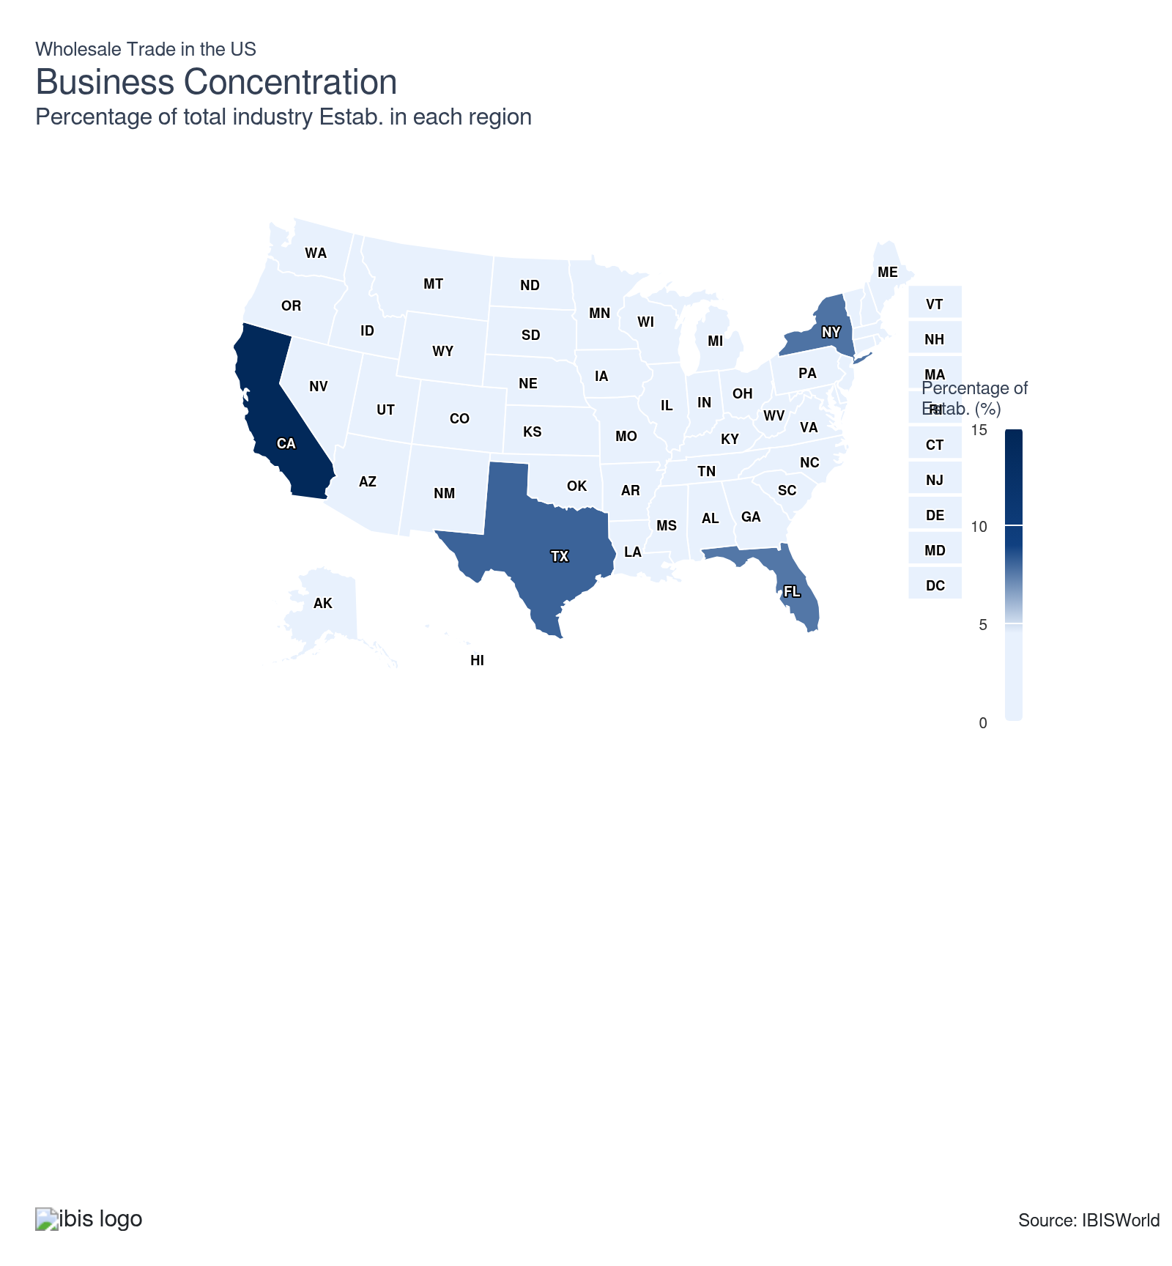
State | Estab.  Units | Estab.  % | Population  %
California | 59353 | 6.9 | 11.5
Texas | 33380 | 3.9 | 9.4
New York | 31785 | 3.7 | 5.8
Florida | 31221 | 3.6 | 7.0
Illinois | 18539 | 2.1 | 3.7
Pennsylvania | 14628 | 1.7 | 3.8
New Jersey | 14060 | 1.6 | 2.8
Ohio | 14035 | 1.6 | 3.5
Georgia | 12928 | 1.5 | 3.3
North Carolina | 11602 | 1.3 | 3.3
Michigan | 11053 | 1.3 | 3.0
Washington | 9283 | 1.1 | 2.3
Indiana | 7668 | 0.9 | 2.0
Massachusetts | 7763 | 0.9 | 2.1
Minnesota | 8032 | 0.9 | 1.7
Missouri | 7705 | 0.9 | 1.8
Colorado | 7219 | 0.8 | 1.8
Virginia | 7073 | 0.8 | 2.6
Wisconsin | 6987 | 0.8 | 1.7
Arizona | 6488 | 0.8 | 2.2
Tennessee | 6779 | 0.8 | 2.1
Alabama | 5315 | 0.6 | 1.5
Louisiana | 5463 | 0.6 | 1.3
Maryland | 5581 | 0.6 | 1.8
Oregon | 5352 | 0.6 | 1.2
Iowa | 4974 | 0.6 | 0.9
South Carolina | 4915 | 0.6 | 1.6
Kansas | 4459 | 0.5 | 0.9
Oklahoma | 4626 | 0.5 | 1.2
Connecticut | 4261 | 0.5 | 1.1
Kentucky | 4293 | 0.5 | 1.3
Utah | 3702 | 0.4 | 1.0
Arkansas | 3418 | 0.4 | 0.9
Nebraska | 3209 | 0.4 | 0.6
Mississippi | 2756 | 0.3 | 0.9
Nevada | 2969 | 0.3 | 1.0
Idaho | 2064 | 0.2 | 0.6
Hawaii | 1661 | 0.2 | 0.4
Maine | 1581 | 0.2 | 0.4
Montana | 1594 | 0.2 | 0.3
New Hampshire | 1839 | 0.2 | 0.4
New Mexico | 1847 | 0.2 | 0.6
North Dakota | 1723 | 0.2 | 0.2
South Dakota | 1507 | 0.2 | 0.3
West Virginia | 1486 | 0.2 | 0.5
Delaware | 1117 | 0.1 | 0.3
Rhode Island | 1328 | 0.2 | 0.3
Alaska | 729 | 0.1 | 0.2
Vermont | 824 | 0.1 | 0.2
Wyoming | 844 | 0.1 | 0.2
District of Columbia | 419 | 0.0 | 0.2

Where are industry businesses located?

The Southeast is a burgeoning manufacturing hub
- Wholesalers increasingly favor the Southeast region because it's a manufacturing powerhouse with strategic access to major consumer markets. This area boasts a robust transportation network, including an extensive system of highways, airports and seaports. These elements collectively enable manufacturers to efficiently distribute goods across the nation.
- The Southeast's strategic geographic location, flanked by the Atlantic Ocean and the Gulf of Mexico, increases its attractiveness to importers and exporters. This positioning offers efficient access to international markets, which is crucial for wholesale operations. The region's ports serve as key gateways for global trade, facilitating the movement of goods to and from international destinations.
- Business-friendly policies further elevate the Southeast's attractiveness. States like Florida stand out with features such as no state income tax and a regulatory environment that's easier to navigate than those in other regions. Such fiscal advantages provide substantial cost savings for companies in the wholesale trade sector, facilitating an influx of businesses aiming to maximize their operational efficiencies.
- Major wholesalers like Sysco have expanded distribution centers in Georgia and Florida to serve the booming manufacturing sector and take advantage of strong logistics infrastructure. In 2022, Sysco opened a new 250,000-square-foot facility near Atlanta, aiming to meet rising demand from regional foodservice customers and streamline shipping with easy access to ports and highways.

A diverse economy and large consumer market bring wholesalers to the West
- Wholesalers are located in the West because of their access to a large consumer market and diverse industry clusters. Regions such as Silicon Valley and Greater Seattle are not only tech hubs but also centers for wholesale distributors of electronic components and computer hardware, capitalizing on proximity to major manufacturers and supply chains.
- With its major cities and dense population centers, the West is a prime location for wholesalers targeting the domestic market. Its urban landscape provides a substantial customer base and a wealth of business opportunities, making it an attractive region for wholesale operations.
- The presence of major ports such as the Port of Los Angeles and the Port of Long Beach further enhances its profile as a leading hub for international trade. These ports are among the busiest in the nation, serving as critical nodes for the import and export of goods. Their advanced infrastructure and capacity support substantial trade volumes, enabling efficient handling and distribution of products.
- The Port of Long Beach processed 9.6 million twenty-foot equivalent units (TEU) in 2024, breaking a record for container volumes set during the pandemic in 2021. This was up approximately 20% year over year. The second-busiest US import gateway reported its best November on record, handling 884,154 TEUs, an increase of 20.9% from the same month a year ago and 12.8% ahead of the previous record set in November 2020.
- Tech-focused wholesalers like Ingram Micro have increased their presence in California to support the region’s electronics and computer hardware market. In 2023, Ingram Micro launched a logistics hub near Los Angeles to speed up deliveries for clients serving Silicon Valley and to tap into high-volume import activity, capitalizing on record-setting throughput at the Port of Long Beach.

The Mid-Atlantic and Great Lakes have historic industrial clusters
- Wholesalers are drawn to the Mid-Atlantic and Great Lakes regions for their high population density and historic industrial foundations. These areas are home to major urban centers such as New York and Chicago, offering wholesalers access to expansive customer bases and enabling efficient distribution to a network of retail outlets. The region's rich industrial history contributes to well-established supply chains and thriving business ecosystems, creating a conducive environment for wholesale trade.
- The Great Lakes region, in particular, is notable for its industrial clusters, particularly in sectors such as automotive and steel. These industries provide wholesalers with essential upstream products necessary for diverse distribution networks. The strength of these clusters enhances the regions’ logistical frameworks, permitting seamless integration and collaboration across the supply chain.
- The Mid-Atlantic and Great Lakes regions are supported by advanced infrastructure, including highways, railways, and major ports such as the Port of New York and New Jersey and the Port of Chicago. These logistical advantages facilitate the smooth, efficient movement of goods domestically and internationally. For instance, the Great Lakes' extensive railway network connects industrial hubs to major markets across the country, significantly benefiting wholesalers by reducing transit times and freight costs.
- In 2023, Grainger expanded operations in the Chicago metro area, leveraging the Great Lakes’ logistics network to serve Midwest manufacturing and industrial clients. Grainger responded to increased demand for industrial supplies with faster regional deliveries, supported by Chicago’s central location and direct rail connections to other major US markets.
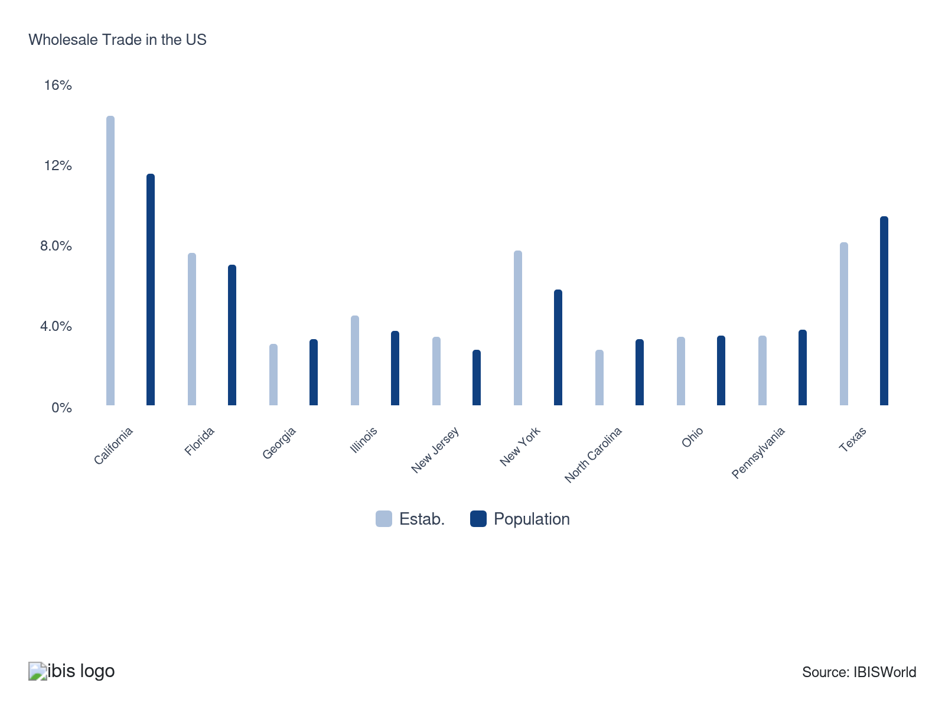

How do businesses use location to their advantage?
Operate in a location that is close to transport
Access to major transportation networks like highways, railroads and ports facilitates the efficient movement of goods, which is critical for maintaining robust distribution channels.
Operate in a location that is close to key markets
Proximity to key markets reduces transportation costs and delivery times, enhancing service speed and reducing operational expenses for wholesalers. It allows for more efficient logistics, ensuring products reach their destinations quickly and cost-effectively.

6. Competitive Forces
https://my.ibisworld.com/us/en/industry/42/competitive-forces

Key Takeaways
- Wholesalers compete aggressively based on price, limiting profit. The lack of significant differences in the goods they offer constrains their ability to secure higher margins through diversification.
- Barriers to entry in the wholesaler sector vary. The ease of entry is affected by several critical elements, including product differentiation and licensing requirements. These factors determine the competitiveness and initial investment needed to enter the wholesale market.

Concentration
Low
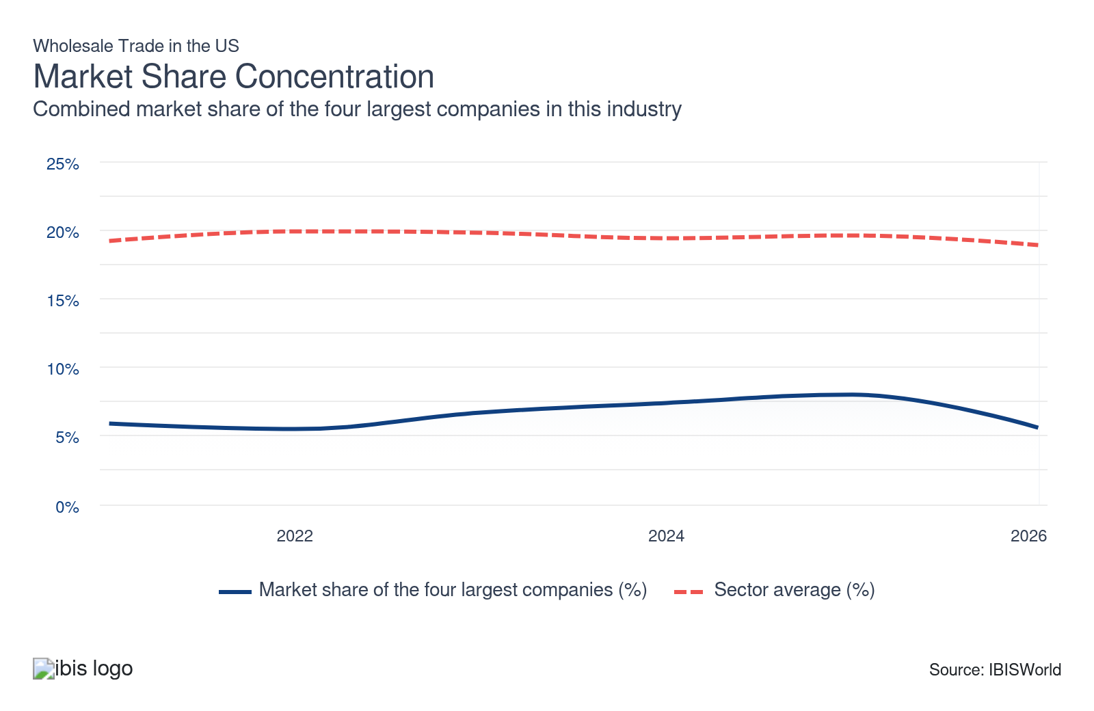

What impacts the industry’s market share concentration?

The vast size of the economy limits companies' scale
- The Wholesale Trade sector is characterized by a vast array of products and services that serve a multitude of industries and regional markets. This broad diversity hinders any one company from monopolizing the sector, leading to a low market share concentration.
- Local wholesalers thrive due to differing regional demand and supply conditions, leveraging their in-depth understanding of specific market needs. This regional specialization fosters a fragmented market structure, further minimizing the potential for any single entity to dominate.
- As a result, the sector remains decentralized, with numerous players distributing market power as they cater to unique regional niches. This dynamic environment fosters robust competition, which, in turn, drives efficiency across the wholesale trade sector.

Some industries are more concentrated than others
- Market concentration in the wholesale trade sector varies by industry due to the nature of the products distributed downstream. The Drug, Cosmetic, and Toiletry Wholesaling industry (IBISWorld report 42421), for instance, demonstrates medium market share concentration because specialized products require established distribution networks, allowing companies like McKesson, AmerisourceBergen, and Cardinal Health to dominate over half of the market.
- In contrast, industries dealing with more uniform products, such as the Fruit and Vegetable Wholesaling industry (IBISWorld report 42448), typically experience low concentration levels. Here, commodities are indistinguishable, reducing entry barriers and enabling numerous smaller players to compete without any major companies overtaking the market. This contrast underscores how product specialization and differentiation significantly influence market concentration across different wholesale industries.

Regional specialization impacts market concentration
- Regional specialization impacts market concentration within the wholesale trade sector. In areas where customer needs or logistical challenges vary, dominant local players emerge, creating a fragmented national market. Regional dynamics highlight the role of localized expertise in shaping market concentration, with local leaders often emerging as vital players due to their deep understanding of regional needs and operational capabilities.
- For instance, the Agricultural Equipment Wholesaling industry (IBISWorld report 42382) might exhibit high regional concentration in areas with extensive farming activities. Here, wholesalers tailor their offerings to meet specific local demands and overcome logistical hurdles associated with rural distribution. This specialization allows them to dominate their local markets while maintaining a fragmented presence nationally.
- Regional wholesalers like CHS in the Midwest have gained an edge by meeting area-specific agricultural needs. During the 2021 supply chain disruptions, CHS increased its inventory of fertilizers and crop protection products specifically for Midwest farmers, ensuring timely delivery when national distributors faced shortages. This move underscored CHS’s deep understanding of local needs and strengthened its market position in the region.

How do successful businesses handle concentration?
Develop a strong reputation
Wholesalers cultivate trust and a strong reputation by being transparent in their operations and business practices. They communicate openly about product quality, pricing and delivery timelines, ensuring customers feel confident in their transactions.
Develop a wide and expanding product range
Companies in wholesale trade overcome concentration by continually expanding their product range. This approach meets diverse customer needs and minimizes dependency on specific market segments, promoting stability and growth.

Barriers to Entry
Low | Steady

What challenges do potential industry entrants face?

Legal
- Legal barriers in the wholesale trade sector are generally low, allowing new entrants more flexibility. However, wholesalers dealing in specialized goods like medical equipment or military supplies face significant regulatory hurdles. Stringent rules require comprehensive compliance measures, including proper documentation, storage protocols and security clearances, making it challenging and cost-prohibitive for new companies to enter these niches.

Start-up Costs
- Wholesalers face considerable financial barriers, including high initial inventory and warehouse infrastructure costs. These start-up expenses fluctuate based on product type and distribution needs, encompassing massive investments in facilities, handling equipment, and advanced technology systems. Consequently, new entrants require substantial capital to build a competitive presence in the market, possibly deterred by the scale of the initial commitment.

Differentiation
- Achieving market differentiation in the saturated wholesale sector is difficult, requiring innovative strategies and strategic partnerships. While product differentiation can significantly enhance a distributor's influence and market control, many industries offer little room for uniqueness. Successful companies leverage unique products or services to distinguish themselves, securing more significant market share and influence over supply chains and pricing.

Labor Expenses
- Labor demands in the wholesale trade sector differ markedly across various industries. In labor-intensive fields, employees are vital in tracking inventory, taking orders and preparing purchase orders. Conversely, capital-intensive wholesalers depend heavily on machinery for stock management. Understanding these distinctions is crucial for optimizing workforce deployment and machinery investment.

How can potential entrants overcome barriers to entry?
Secure economies of scale
Securing economies of scale allows wholesale traders to lower unit costs significantly, enhancing their competitive edge by offering lower prices while maintaining profitability.
Secure distribution channels
By developing a robust distribution network, wholesalers ensure timely delivery to diverse geographic markets, improving service levels and effectively expanding their customer base.

Substitutes
Moderate | Steady

What are substitutes for industry services?

Direct manufacturer-to-retailer sales
- Third-party wholesalers compete fiercely with manufacturers' sales branch offices (MSBOs) in numerous industries. With the evolving business landscape, retailers have increasingly bypassed wholesalers, opting to buy directly from manufacturers. This shift streamlines the supply chain, reduces intermediary costs, and provides retailers with potential pricing advantages.
- By embracing direct sales, retailers gain enhanced control over inventory and enjoy a more agile response to their unique needs. This fosters stronger collaboration in product development and marketing strategies, thereby diminishing the dependence on traditional wholesale channels and encouraging innovation in distribution.

E-commerce platforms
- Online e-commerce platforms have revolutionized the way retailers connect with suppliers and manufacturers worldwide, offering an expansive array of product choices. These platforms streamline procurement processes and often provide competitive pricing that challenges traditional wholesale methods.
- By leveraging e-commerce, retailers of all sizes can efficiently source products, frequently at lower costs than conventional channels. This technology minimizes the need for intermediaries, posing a significant challenge to traditional wholesalers. Consequently, retailers enjoy increased flexibility, broader market access and the ability to adapt swiftly to consumer demands.

How do successful businesses compete with substitutes?
Secure access to well-established brand names
Wholesale trade companies secure well-established brand names to foster strong customer loyalty. Recognized brands assure customers of consistent quality, reducing the likelihood of switching to substitutes. This strategy is crucial in industries where product quality is highly valued but less critical for wholesalers of undifferentiated products.
Keep running costs low
Wholesalers stock a diverse and ever-changing range of products to align with market trends. By optimizing resource use and minimizing warehousing costs, they reduce overhead expenses. Streamlined processes and efficiency measures allow them to offer competitive prices without sacrificing quality to effectively meet demand.

Buyer & Supplier Power
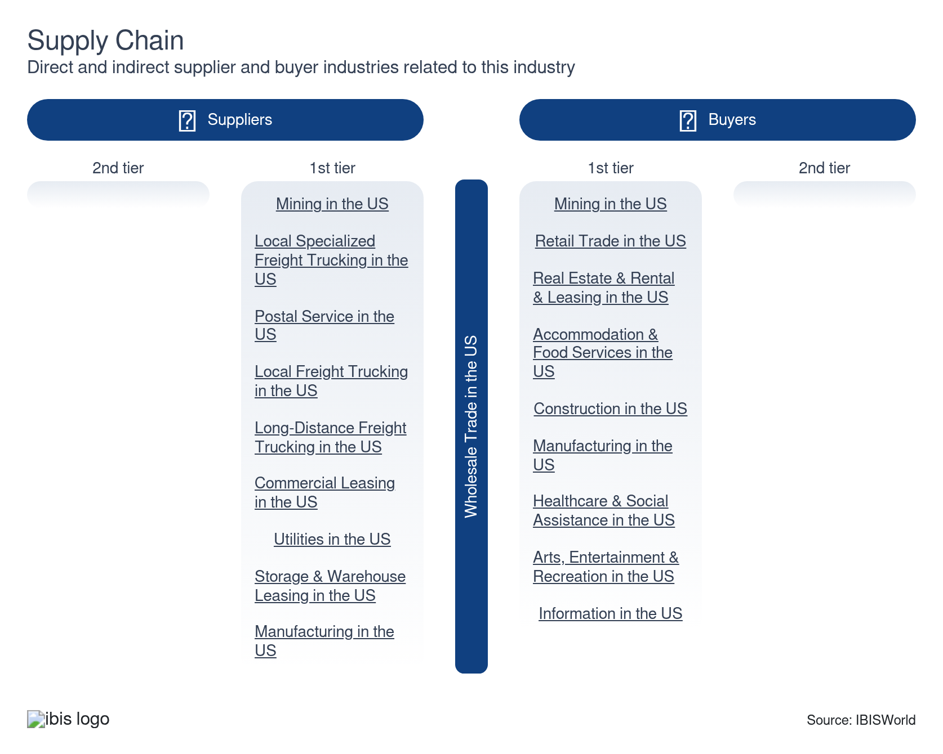

What power do buyers and suppliers have over the industry?

Buyers: bulk purchases and pressure
Moderate | Steady
- Labor demands vary significantly across industries in the wholesale trade sector. In labor-intensive sectors, employees are essential for inventory tracking, order taking and purchase order preparation. These roles necessitate hands-on involvement, emphasizing the need for efficient workforce management.
- Capital-intensive wholesalers depend heavily on advanced machinery and technology for managing inventory and daily tasks. They invest in automated systems that streamline processes, help minimize mistakes and cut labor costs. Many also use robotics or AI for faster order fulfillment and real-time supply tracking.
- Buyers dictate the competitive dynamics among wholesalers, who can easily switch suppliers to find the best deals. This forces wholesalers to provide competitive pricing and personalized services to retain their clientele. The ability to balance labor and technology investments while responding to market competition is critical for success in the wholesale trade.

Suppliers: large companies exert pressure
Moderate | Steady
- In niche markets, suppliers with control over unique products often wield substantial influence, dictating both pricing and availability. This power dynamic challenges wholesalers to rely heavily on these specialized goods. They face higher costs and potential supply disruptions, which can impact their operational stability.
- Large suppliers amplify their influence by diversifying their product lines, increasing wholesalers' dependency on them for a broader range of offerings. This dependency significantly diminishes wholesalers' bargaining power, forcing them to accept less favorable terms. Such constraints can adversely affect profitability, as wholesalers may struggle to negotiate better prices or manage supply chain disruptions effectively.
- Consequently, the strategic positioning of suppliers in niche markets requires wholesalers to carefully navigate these relationships, balancing their need for unique products with the risks of supplier dependency. Understanding these dynamics is crucial for wholesalers aiming to maintain a competitive edge.

How do successful businesses manage buyer & supplier power?
Leverage upstream vertical integration
Wholesale businesses leverage upstream integration to enhance their bargaining position with suppliers. This control allows them to negotiate better terms and costs, improving margins and more competitive pricing for their customers.
Pass on cost increases
Wholesalers mitigate supplier power by transferring increased costs to consumers. By adjusting prices responsibly, they buffer against unexpected supplier rate hikes, keeping the business financially healthy while remaining competitive.

7. Companies
https://my.ibisworld.com/us/en/industry/42/companies

Key Takeaways
- McKesson is the largest healthcare company in the U.S. and ninth on the Fortune 500 by revenue. McKesson's revenue places it among the top American corporations.
- Concentration in medical supplies wholesaling is notably higher than in other industries. McKesson, Cencora (formerly AmerisourceBergen) and Cardinal Health dominate the market, distributing billions of dollars in goods.

Market Share
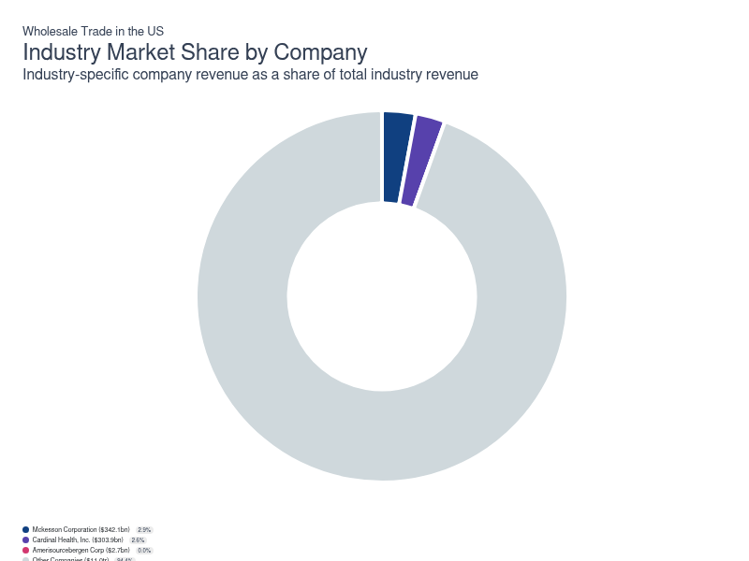
Chart displays current year only in the PDF version of this report. You can view and download chart for all other years associated with this industry on my.ibisworld.com.

Companies
Company | Market Share (%)  2026 | Revenue ($m)  2026 | Profit ($m)  2026 | Profit Margin (%)  2026
Mckesson Corporation | 2.9 | 342,089.3 | 4,692.1 | 1.4
Cardinal Health, Inc. | 2.6 | 303,895.3 | -1,012.5 | -0.3
Amerisourcebergen Corp | 0.0 | 2,657.9 | 575.9 | 21.7

Mckesson Corporation
Mckesson Corporation
Company Details
Company Details
Industry Specific Revenue (2026) | $342.1bn
Industry Profit (2026) | $4.7bn
Company Employees (2026) | 45,000
Market Share (2026) | 2.9%

Description
Description
Mckesson is a public company headquartered in Texas with an estimated 45,000 employees. In the US, the company has a notable market share in at least two industries: Wholesale Trade, Drug, Cosmetic & Toiletry Wholesaling and Wholesale Trade. Their largest market share is in the Drug, Cosmetic & Toiletry Wholesaling industry, where they account for an estimated 24.0% of total industry revenue and are considered an All Star because they display stronger market share, profit and revenue growth compared to their peers.

Brands and Trading Names
Brands and Trading Names
- Major Pharmaceuticals
- McKesson
- NorthStar Rx
- Pfizer
- Teva

Other Industries
Other Industries
- Drug, Cosmetic & Toiletry Wholesaling in the US

Company’s Industry Revenue, Market Share, and Profit Margin Over Time
Company’s Industry Revenue, Market Share, and Profit Margin Over Time
Year | Industry Revenue ($ million) | Market Share (%) | Profit Margin (%)
2020 | 181700 | 2.2 | 1.1
2021 | 189274 | 1.9 | -2.1
2022 | 212149 | 1.9 | 0.8
2023 | 240616 | 2.3 | 1.6
2024 | 278739 | 2.6 | 1.3
2025 | 329260 | 2.9 | 0.9
2026 | 342089 | 2.9 | 1.4

What's impacting Mckesson Corporation's performance?

Company grows with acquisition of Rx Savings Solutions
- In October 2022, McKesson finalized its acquisition of Rx Savings Solutions, integrating it into its Prescription Technology Solutions segment. This move allows McKesson to expand its personalized price transparency and medication savings tools for patients and healthcare providers. The combined services are designed to help users make informed medication choices and lower out-of-pocket costs, enhancing the overall patient pharmaceutical experience.

McKesson enters agreement with Independent Pharmacy Cooperative
- In June 2024, McKesson expanded its position in pharmaceutical distribution with the recent supply agreement established with the Independent Pharmacy Cooperative (IPC), a group purchasing organization of community pharmacies. This partnership will expand McKesson’s engagement with independent pharmacies by providing them with tailored pricing options. By offering two distinct pricing models, McKesson will offer two distinct pricing models to strengthen relationships with IPC member pharmacies. The agreement will also allow McKesson to leverage its advanced digital health platform.

McKesson reshapes segments around North American pharma
- In September 2025, McKesson announced a new four-segment operating structure built around North American pharmaceuticals, oncology and multispecialty services, prescription technology solutions and medical-surgical solutions. This reorganization combines US and Canadian drug distribution into a single North American Pharmaceutical Services unit, improving scale and coordination. The oncology and multispecialty segment is positioned as a focused growth platform. Prescription technology solutions concentrate on adherence, access, and data-driven services, while medical-surgical solutions remain a distinct platform serving hospital, clinic, and non-acute care customers.
Cardinal Health, Inc.
Cardinal Health, Inc.
Company Details
Company Details
Industry Specific Revenue (2026) | $303.9bn
Industry Profit (2026) | -$1.0bn
Company Employees (2026) | 48,000
Market Share (2026) | 2.6%

Description
Description
Cardinal Health is a public company headquartered in Ohio with an estimated 48,000 employees. In the US, the company has a notable market share in at least three industries: Wholesale Trade, Medical Supply Wholesaling, Drug, Cosmetic & Toiletry Wholesaling and Wholesale Trade. Their largest market share is in the Drug, Cosmetic & Toiletry Wholesaling industry, where they account for an estimated 14.9% of total industry revenue.

Brands and Trading Names
Brands and Trading Names
- Abilene Nuclear, LLC
- Allegiance Corporation
- API (Suppliers) Limited
- Arch Collection Corporation
- Beckloff Assoiciates, Ince.
- Borschow Hospital & Medical Supplies
- C. International
- Cardinal Distribution Holdings Corporation
- Martinizing Dry Cleaning

Other Industries
Other Industries
- Drug, Cosmetic & Toiletry Wholesaling in the US
- Medical Supply Wholesaling in the US

Company’s Industry Revenue, Market Share, and Profit Margin Over Time
Company’s Industry Revenue, Market Share, and Profit Margin Over Time
Year | Industry Revenue ($ million) | Market Share (%) | Profit Margin (%)
2020 | 177106 | 2.2 | 1.4
2021 | 191788 | 2.0 | -1.6
2022 | 208261 | 1.8 | 0.5
2023 | 234110 | 2.2 | 0.1
2024 | 255012 | 2.4 | 0.6
2025 | 282024 | 2.5 | 0.7
2026 | 303895 | 2.6 | -0.3

What's impacting Cardinal Health, Inc.'s performance?

Cardinal Health's partnership with Kinaxis has streamlined its distribution channels
- On February 9, 2022, Cardinal Health announced a partnership with supply chain company Kinaxis to digitize its supply chain management and planning. The partnership will see Cardinal Health utilizing Kinaxis's RapidResponse platforms to keep track of the company's supply chain digitally. The rollout the RapidReponse platform, which was completed by the end of 2023, helps Cardinal Health optimize its supply chain and meet its clients' demands.

Cardinal Health's new distribution facilities strengthen the supply chain
- Cardinal Health is investing in infrastructure to strengthen its supply chain. The company recently opened a new Consumer Health Logistics Center in Groveport, Ohio, to act as a replenishment hub for health product inventory. This center features robots, automated labeling and high-speed conveyors to boost efficiency in the supply chain. This is the company's most recent expansion, as it focuses on meeting consumers' increasing need for health products.

Cardinal Health accelerates automated pharmaceutical logistics network transformation
- Starting in mid-2025, Cardinal Health began a multi-year modernization of its pharmaceutical logistics network. The Consumer Health Logistics Center in Ohio became operational around mid-2025, adding capacity and efficiency for consumer-health and pharmaceutical products. In late 2025, the company detailed plans for a new flagship forward pharmaceutical distribution center in Indianapolis that will feature an industry-first robotic storage and retrieval system and broader automation. Framed as the “next chapter” of Cardinal’s logistics strategy, these projects are scheduled over several years to lift productivity, service quality and workplace safety.
Amerisourcebergen Corp
Amerisourcebergen Corp
Company Details
Company Details
Industry Specific Revenue (2026) | $2.7bn
Industry Profit (2026) | $575.9m
Company Employees (2026) | 46,000
Market Share (2026) | 0.0%

Description
Description
Amerisourcebergen is a public company headquartered in Pennsylvania with an estimated 46,000 employees. In the US, the company has a notable market share in at least two industries: Drug, Cosmetic & Toiletry Wholesaling and Wholesale Trade. Their largest market share is in the Drug, Cosmetic & Toiletry Wholesaling industry, where they account for an estimated 21.2% of total industry revenue and are considered a Disruptor because they display lower to medium market share that’s rising rapidly, but weaker profits compared to some of their peers.

Brands and Trading Names
Brands and Trading Names
- Alliance Healthcare
- ASD Healthcare
- Besse Medical
- HealthForward
- ICS
- Innomar Strategies
- IntrinsiQ Specialty Solutions
- ION Solutions
- IPN Solutions
- Lash Group
- Micro Technologies
- MWI Animal Health
- MWI Animal Health U.K.
- Oncology Supply
- Securos Surgical
- US Bioservices
- World Courier
- Xcenda

Other Industries
Other Industries
- Drug, Cosmetic & Toiletry Wholesaling in the US

Company’s Industry Revenue, Market Share, and Profit Margin Over Time
Company’s Industry Revenue, Market Share, and Profit Margin Over Time
Year | Industry Revenue ($ million) | Market Share (%) | Profit Margin (%)
2020 | 168829 | 2.1 | -2.7
2021 | 197777 | 2.0 | 1.1
2022 | 207284 | 1.8 | 1.0
2023 | 229717 | 2.2 | 0.9
2024 | 259974 | 2.4 | 0.7
2025 | 289129 | 2.6 | 0.9
2026 | 2658 | 0.0 | 21.7

What's impacting Amerisourcebergen Corp's performance?

Cencora transitions from AmerisourceBergen as it focuses on growth
- On August 30, 2023, AmerisourceBergen Corporation officially rebranded as Cencora, marking a significant change in its corporate identity. The company now trades on the New York Stock Exchange under the new ticker symbol "COR," replacing the previous "ABC." Cencora's new name is intended to encapsulate its focus on connecting various stakeholders in the healthcare sector. The company plans to maintain its focus on pharmaceutical distribution while expanding into pharma and biopharma services.

Cencora commits billion-dollar push to modernize us network
- In November 2025, Cencora (operating under its rebranded name from AmerisourceBergen) outlined a long-term plan to invest about $1 billion in its U.S. pharmaceutical distribution network through 2030. The program funds new national and regional distribution centers, expanded specialty and cold-chain capacity, and highly automated facilities. These investments are intended to increase throughput, reduce operating costs and improve service reliability. By phasing projects over 2025–2030, Cencora aims to align capacity with rising drug volumes and the growing complexity of specialty therapies and customer expectations.

AmerisourceBergen completes acquisition of Alliance Healthcare Business
- In June 2021, AmerisourceBergen (ABC) significantly strengthened its position by completing the acquisition of Walgreens Alliance Healthcare Business. This strategic move expanded ABC's global manufacturing services, enhancing its pharmaceutical wholesaling, logistics, and clinical trial capabilities. As a result, ABC now holds a more robust portfolio, positioning itself as a more formidable player in the global pharmaceutical landscape. This acquisition broadens ABC's reach and amplifies its operational efficiency, enabling the company to deliver comprehensive and efficient solutions across its services.

You can view and download company details on my.ibisworld.com.

8. External Environment
https://my.ibisworld.com/us/en/industry/42/external-environment

Key Takeaways
- Upstream market policies indirectly impact the wholesaling process. Changes in regulations affecting manufacturing and production can have cascading effects on supply chains and distribution strategies employed by wholesalers.
- Wholesale traders involved in international trade depend significantly on Export-Import Bank guarantees. These and other government programs provide vital financial assistance, facilitating their operations in global markets.

External Drivers

What demographic and macroeconomic factors impact the industry?
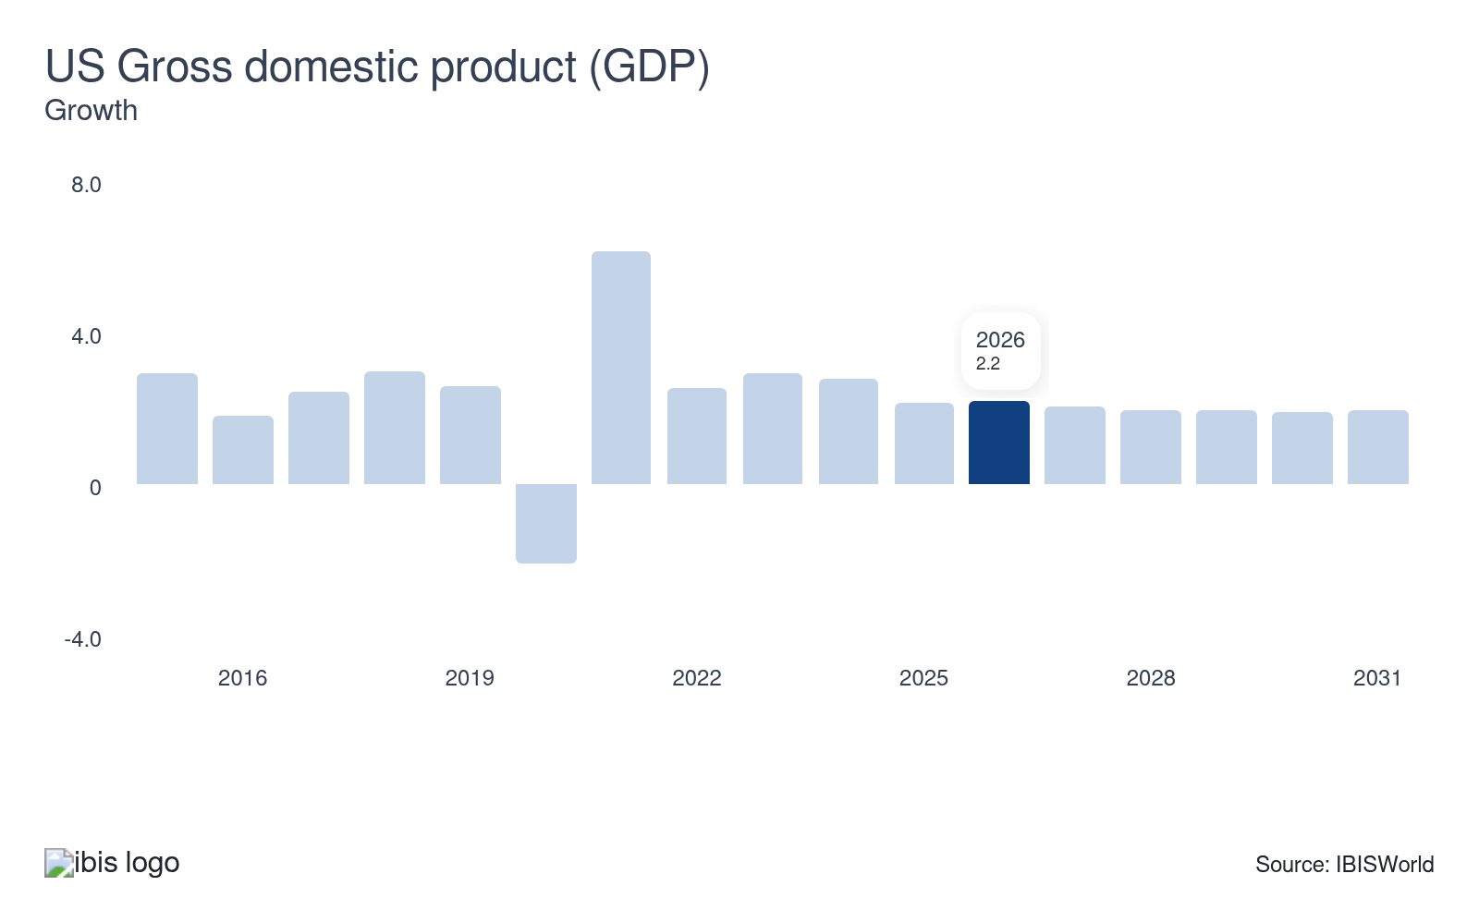
The performance of the US economy significantly affects demand for exports and the price and demand for imports. For example, during periods of weak economic growth, retail spending is modest, which negatively affects demand for goods at the wholesale level. A country's currency performance compared with its major trading partners’ currencies also affects demand for internationally imported goods.
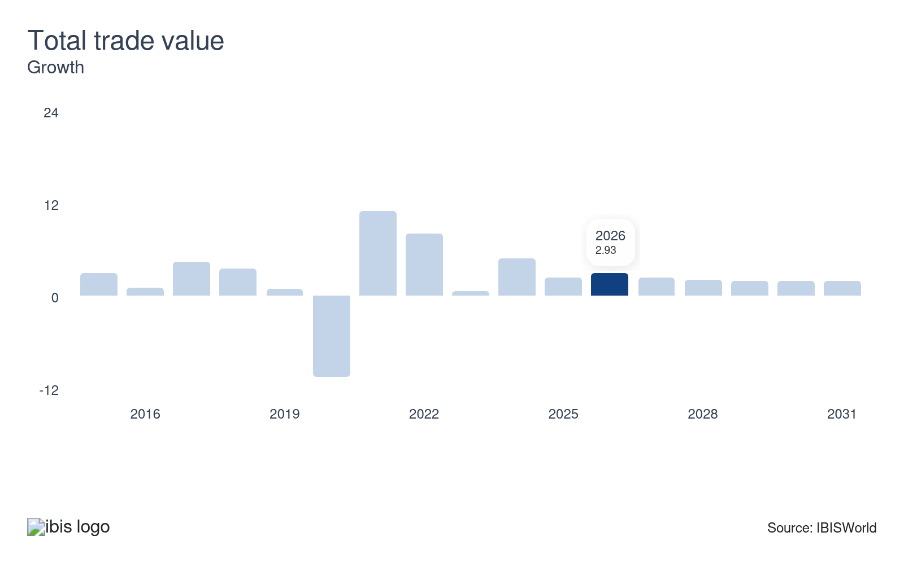
The performance of wholesalers closely tracks total trade value, which reflects the flow of goods and services across US borders. When imports and exports fall, wholesalers see weaker demand from manufacturers and retailers. If trade value rises, wholesalers often report busier warehouses and more shipments, driven by strong consumer demand and global supply chain activity. Thus, any decline in total trade poses a potential threat to the wholesale sector.
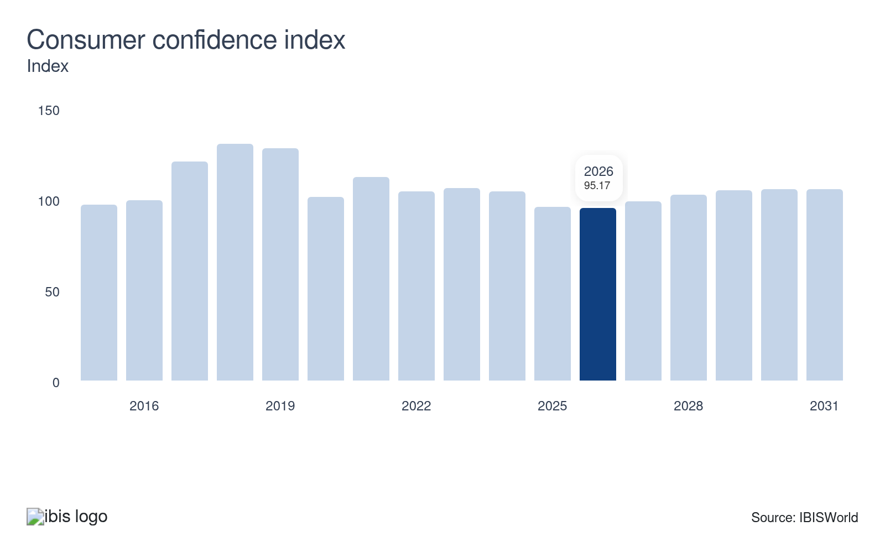
Consumer sentiment fluctuations directly impact retail demand, rippling through to the wholesale sector. When consumers feel optimistic, retail demand spikes, leading wholesalers to increase inventory and sales efforts. Conversely, pessimistic sentiment causes reduced consumer spending, prompting retailers to lower orders and impacting wholesalers’ sales volumes. Thus improvement in consumer sentiment represents a potential opportunity for the sector.
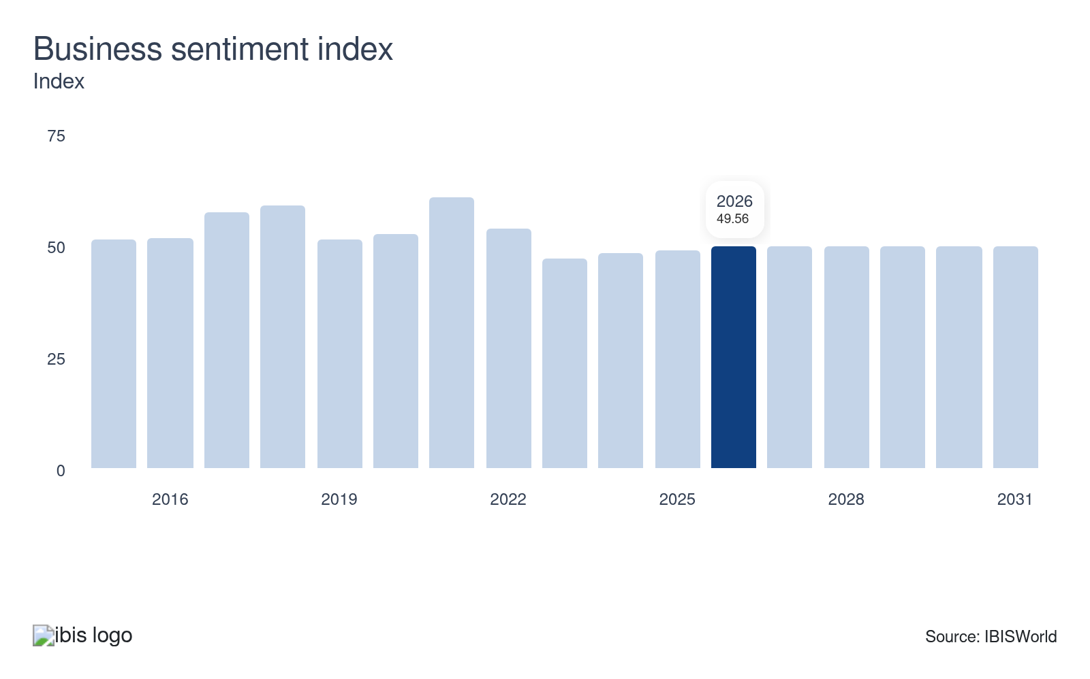
The business sentiment index mirrors private sector confidence and shapes business spending patterns. When the index rises, businesses ramp up spending on goods, driving demand through wholesale channels. Conversely, a decline in sentiment curtails business expenditures, reducing wholesale orders and impacting revenues. In times of rising inflation, a declining index amplifies hesitation among private companies, resulting in cautious purchasing and negatively affecting the sector's growth.

Regulation & Policy
Low | Steady

What regulations impact the industry?

Environmental Protection Agency (EPA) regulations
EPA regulations mandate wholesalers adhere to environmental best practices, especially in waste management and emissions. These regulations require wholesalers to implement environmentally conscious waste-management and emissions-reduction strategies. For example, a wholesaler of industrial solvents must use advanced storage systems to prevent leaks and invest in safe disposal technologies to avoid environmental harm. By doing so, the wholesaler ensures compliance and enhances their reputation for responsibility and sustainability. This commitment to eco-friendly practices promotes trust among consumers and partners.

Federal Trade Commission (FTC) Act
The FTC Act is crucial in maintaining fair competition and honest marketing within wholesale trade. For example, furniture wholesalers must provide clear, accurate descriptions and pricing for bulk orders. Misleading claims about the sustainability of wood used or the durability of products could lead to significant penalties and a tarnished reputation. This underscores the necessity for truthful advertising and precise product labeling. Wholesalers that adhere to these regulations avoid fines and build trust with retailers and consumers, ultimately fostering long-term business success.

Occupational Safety and Health Administration (OSHA) standards
OSHA's standards are pivotal in maintaining safe and healthy environments in the wholesale trade, particularly in warehousing and physical goods-handling operations. For instance, a food and beverage wholesaler with extensive storage facilities must comply with OSHA's guidelines by ensuring all lifting equipment, such as forklifts, are routinely inspected and maintained. Clear emergency exits must also be marked, and employees should undergo regular training sessions on safe handling practices and procedures. By adhering to these regulations, wholesalers can significantly reduce the risk of workplace accidents, minimize potential liabilities and ensure a safer workspace for their employees, thereby enhancing overall operational efficiency and employee morale.

Federal Food, Drug, and Cosmetic Act (FD&C Act)
The FD&C Act is vital for maintaining safety and quality in the wholesale distribution of food, beverages and cosmetics, mandating that these products are safe, wholesome and accurately labelled. For example, a wholesaler of organic skincare products must comply with strict FDA guidelines, ensuring all labels accurately represent ingredient compositions and verify the absence of harmful substances. This requires diligent record-keeping and robust quality control processes to ensure compliance. Adhering to these regulations minimizes legal risks and enhances consumer trust in product safety and quality, contributing to a strong business reputation.

Consumer Product Safety Commission (CPSC)
The CPSC enforces crucial product safety regulations. Wholesalers importing or distributing children's products must ensure these items meet stringent safety standards. For instance, a toy wholesaler must confirm that all products are free of lead and phthalates, which requires considerable investment in testing and certification. Furthermore, the FHSA mandates hazard labelling and bans hazardous items. Wholesalers of cleaning supplies or art materials must display hazard warnings and ensure that containers are child-resistant, preventing accidents and encouraging careful product selection.

Perishable Agricultural Commodities Act (PACA)
The PACA mandates that businesses obtain a license to trade legally, ensuring fairness and trust. A fresh produce wholesaler, for instance, must be licensed to sell tomatoes and lettuce, reducing fraud risks and fostering ethical practices. PACA also enforces honesty, requiring wholesalers to accurately represent product quality and quantity. For example, a wholesaler of organic apples must be transparent about their grade, minimizing disputes and enhancing buyer trust. Compliance builds long-term industry relationships.

Petroleum reporting requirements
Petroleum bulk storage facilities must comply with Section 313 of the Emergency Planning and Community Right-to-Know Act of 1986 (EPCRA) and Section 6607 of the Pollution Prevention Act of 1990 (PPA), also known as the Toxic Release Inventory (TRI). These facilities are required to report annually on chemical releases and waste management. Additionally, wholesalers must label motor fuels that contain alcohol. Compliance ensures transparency in environmental impact and promotes safety for communities and consumers.

Department of Defense (DoD) rules
The DoD impacts the US wholesale trade sector through regulations ensuring national security and proper procurement. The Defense Federal Acquisition Regulation Supplement (DFARS) and the Berry Amendment are key regulations. Wholesalers must comply with DFARS, including strict cybersecurity standards, which enhances security but requires investment in IT infrastructure. The Berry Amendment mandates sourcing American-made products, like military uniforms, supporting local manufacturing but potentially raising costs. Compliance ensures eligibility for lucrative DoD contracts, demanding rigorous quality and safety checks.

Assistance
Low | Steady

What assistance is available to this industry?

Small Business Administration (SBA) loans
Wholesale traders have a valuable resource in SBA loan programs, notably the 7(a) loan, which can be crucial for financing needs that traditional banks might be hesitant to meet. Given the substantial capital required for wholesale transactions, the 7(a) loan helps cover diverse financial needs, from purchasing inventory and equipment to acquiring real estate. For instance, a wholesale distributor looking to expand its warehouse facility could leverage this loan to overcome liquidity constraints, enabling more efficient operational scaling.

Export-Import Bank of the United States (EXIM) guarantees
EXIM guarantees provide vital financial backing for wholesalers engaged in international trade. Through its guarantees and insurance programs, EXIM helps US exporters mitigate the risk of non-payment from international buyers, especially when dealing with large international orders. For example, a US-based electronics wholesaler exporting to emerging markets may face risks from political instability or currency fluctuations. EXIM support ensures wholesalers maintain the cashflow stability necessary to manage substantial inventory levels and adhere to operational cycles.

Federal Trade Zones (FTZ)
Operating within an FTZ offers wholesalers substantial financial advantages by deferring US import duties until goods enter domestic commerce. This deferment can lead to significant cost reductions related to customs duties, thereby improving cash flow and easing inventory management. For example, a wholesale clothing distributor can store imported garments in an FTZ without immediately incurring import taxes, allowing them to manage shipping schedules according to market demand. Furthermore, if the goods are re-exported, the wholesaler might even avoid these duties altogether, enhancing competitiveness in global markets by lowering overall operational costs. This strategic use of FTZs can help wholesalers optimize their financial planning.

Trade Adjustment Assistance (TAA)
TAA is specifically designed to support companies adversely affected by import competition. TAA provides financial aid to help wholesalers develop and execute business recovery strategies amid challenges in overseas markets. This support is crucial for funding key adjustments or innovations to restore competitiveness. For instance, a wholesale furniture importer facing increased competition from low-cost countries might use TAA funds to invest in advanced inventory management technologies or explore new distribution channels, thereby streamlining operations and improving market responsiveness.

Trade associations
Wholesale trade associations play a vital role in supporting distributors across numerous industries by providing essential professional and operational resources. For example, the National Association of Wholesaler-Distributors offers members access to training programs, industry benchmarking tools and valuable networking events that foster collaboration and innovation. Beyond education, it actively represents member interests through government lobbying and by monitoring new legislation or regulatory changes that may impact wholesale operations. Likewise, the Aviation Suppliers Association performs similar functions for aviation distributors while also granting specialized accreditations that strengthen industry credibility and compliance. By promoting best practices and connecting professionals, such associations help businesses remain efficient, competitive and adaptable in an ever-changing global marketplace where regulatory awareness and professional development are key to long-term success.

9. Financial Benchmarks
https://my.ibisworld.com/us/en/industry/42/financial-benchmarks
Profit Margin  4.4 %  ↑ Higher than sector | Average Wage  $90,444  ↑ Higher than sector | Largest Cost  Purchases  78.8% of Revenue

Key Takeaways
- Purchase costs constitute the majority of revenue across all industries. However, commodity price fluctuations and bargaining dynamics influence cost variability across industries. The interactions between upstream manufacturers and distributors shape the final expenditure at the wholesale trade level.
- Cost categories show significant variation across wholesaling industries. Wholesaling industries handling high-value, low-volume products require less warehouse space. This logistical efficiency can lead to lower rent costs, influencing their overall cost structure.

Cost Structure
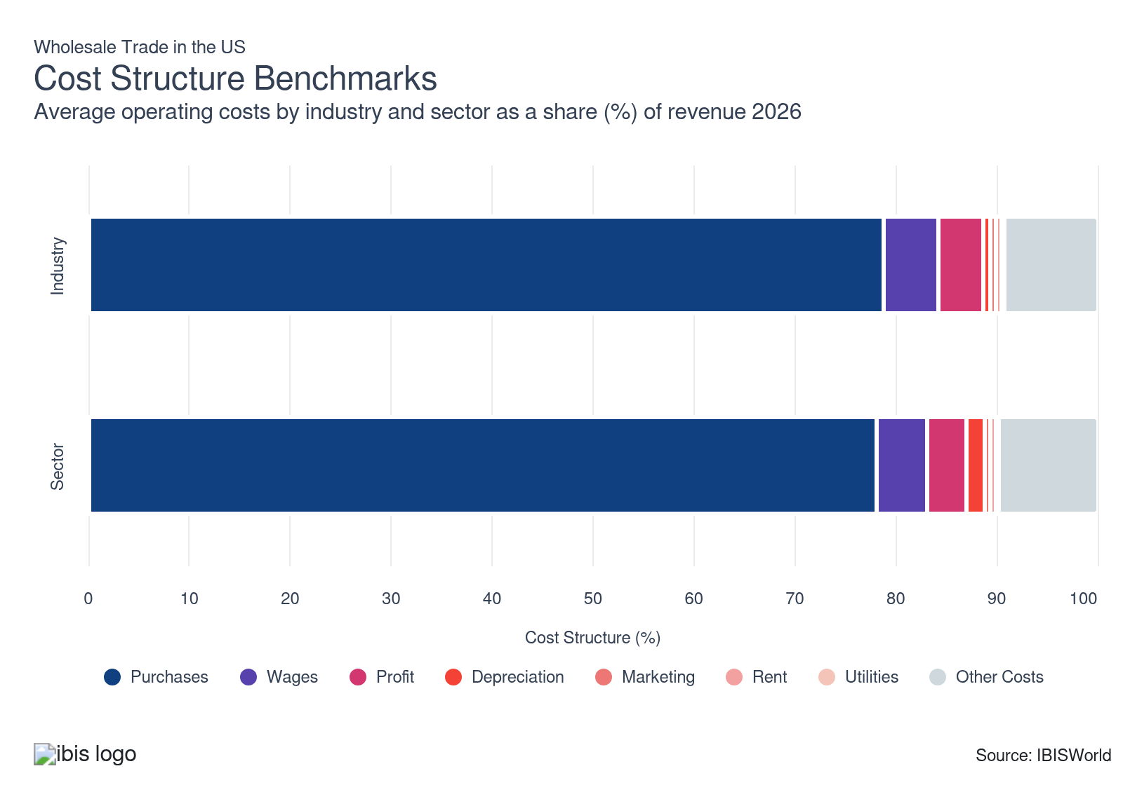
Chart displays current year only in the PDF version of this report. You can view and download chart for all other years associated with this industry on my.ibisworld.com.

What trends impact industry costs?

Purchase costs are directly influenced by raw material prices
- Purchases consist of products purchased from vendors, manufacturers and wholesalers, either domestically or internationally, for resale to several markets, including exports, restaurants and hotels, other wholesalers and retailers. Many wholesalers sourced inventory from overseas suppliers, adapting quickly to shifts in global supply chain demands.
- Revenue from purchases hinges on the raw material demands of downstream industries and commodity prices. Crude oil prices play a crucial role in transportation costs, as most goods are transported by long-haul trucks. Fluctuations in oil prices directly impact logistics expenses.
- Wholesalers prioritize strategic partnerships with suppliers, aiming to secure volume discounts and favorable terms. These collaborations are crucial in stabilizing purchase costs relative to revenue, providing a buffer against fluctuating market conditions and helping maintain competitive pricing.
- Inflation has increased operating costs for wholesalers, compelling them to increase capital expenditures for new equipment. The ongoing conflict in the Middle East has pushed up global crude oil and natural gas prices, potentially increasing wholesale costs. In the days immediately after the Iran conflict broke out, crude oil benchmarks such as Brent and WTI jumped sharply, reflecting heightened supply and transport risks in the Gulf region.
- These higher energy inputs could raise purchase and logistics expenses, squeezing margins and pressuring wholesale prices across downstream markets. To stay competitive, businesses are investing more in modernizing their operations, despite elevated spending, to enhance efficiency and offset the inflation-driven financial impact on their bottom lines.

Sector-wide profits remain low, with inflation exerting significant pressure
- Wholesale trade's profitability heavily relies on the broader economic landscape. Factors like market regulations, global trade policies, and competition levels actively shape the sector's success. The pursuit of diverse revenue streams, such as value-added services and e-commerce capabilities, is helping wholesalers maintain stable profit margins. Providing services such as logistics solutions or customized packaging can enhance revenue without significantly increasing overhead.
- Wholesalers increasingly invest in automation and technology to improve operational efficiency and cut labor and logistics costs. For example, Walmart's blockchain implementation for supply chain management shows how tech upgrades can streamline operations and minimize waste. By enhancing efficiency, wholesalers can better navigate pricing pressures, maintain or even grow profit margins and effectively protect their bottom line in a competitive environment.
- Wholesale prices have continued to rise, with the PPI rising 3.3% in 2024, well ahead of the 1.1% increase in 2023 according to the Bureau of Labor Statistics. Companies have find it harder to pass these increased costs on to downstream retailers, challenging their ability to maintain profitability. Still, with the bulk of disruptions brought about by the pandemic in the rear view mirror, wholesalers have managed to raise profitability.

Labor remains crucial even as wholesalers struggle to fill open positions
- While wholesale trade has historically been labor-intensive, the introduction of equipment and machinery and the use of computer systems have limited reliance on labor. Wage costs are shaped by several factors, including the nature of goods stored and transported, the scale of operations and the workforce size. These elements determine labor requirements and, consequently, overall wage expenditures within individual wholesale industries
- The Flower and Nursery Stock Wholesaling industry (IBISWorld report 42493) and the Used Car Parts Wholesaling industry (42314) have high labor costs. In contrast, the Gasoline and Petroleum Wholesaling industry (42472) and Gasoline and Petroleum Bulk Stations industry (42471) have low labor costs.
- Wages have stabilized across the wholesale sector in recent years. The post-pandemic period was marked by a tight labor market, making it challenging for companies to attract new talent. To cope, many businesses turned to automation as a substitute for human labor.
- Following a sharp rise in 2020, wages contracted as a share of revenue in 2021 and 2022. Still, they are expected to climb as a share of revenue from 2021 to 2026, from 5.1% to 5.4% of revenue, respectively.

Capital expenses are typically minimal for wholesalers
- Capital expenditure remains minimal in the wholesale trade sector, resulting in depreciation accounting for a relatively small share of revenue. Depreciable assets typically include buildings, storage equipment, machinery for product movement, and computer inventory systems.
- Depreciation expenses in wholesale trade have remained stable in recent years, highlighting a conservative approach to investing in new infrastructure. In contrast, distribution and logistics expenses have increased, attributed to the growing costs associated with upgrading vehicle fleets, as well as ongoing maintenance and repair.

The shortage of industrial facilities is set to raise the cost of rent
- Rent expenses represent a small share of revenue across wholesalers trade. Wholesalers predominantly operate from their own distribution centers and offices, limiting their reliance on leased facilities and equipment.
- However, warehouse costs can fluctuate significantly based on location. A shortage of older industrial buildings in prime urban and suburban areas has intensified competition for such properties, often viewed as outdated but now prized as "Last Mile" warehouses. Typically under 200,000 square feet, these properties attract investors interested in industrial and warehouse assets.
- With Amazon and other e-commerce fulfillment organizations responsible for roughly 40.0% of industrial property leases in the US, rental costs are poised to rise as these giants expand their logistical operations, signaling a shift in the sector's economic landscape.

Wholesalers are turning to alternative energy sources to better manage overhead
- Utilities, encompassing heat, electricity, water and other operational expenses, are crucial components for wholesalers. Regular maintenance, necessary to ensure equipment safety and functionality, often demands significant energy, as tasks like repairs, quality checks, and cleaning typically involve power tools and heavy machinery.
- Effectively managing these utility costs is essential for controlling overheads and meeting sustainability goals, which are increasingly important to consumers and regulators alike. With energy prices escalating, wholesalers are proactively exploring renewable energy sources and investing in energy-efficient equipment.

The insurance market for wholesale trade has experienced a transformative shift
- Wholesalers typically invest in comprehensive insurance policies to safeguard their operations. This includes property insurance to protect physical assets, and general liability insurance to cover against third-party claims of bodily injury or property damage. They also secure product liability insurance to address potential risks related to the products they distribute. Business interruption insurance is another key policy, covering lost income during unexpected disruptions.
- From 2010 to 2020, the wholesale insurance market underwent transformative shifts. Before 2010, retail agencies often bypassed wholesalers, preferring direct approaches, but rising loss ratios made this strategy unsustainable. Retailers then turned to wholesalers for better access to the adaptable excess and surplus lines (E&S) markets.
- Major wholesalers pushed to consolidate retailer partnerships and revolutionize industry practices. Meanwhile, private equity firms streamlined operations by acquiring retail agencies and centralizing wholesaler relationships. The E&S market has thrived, with S&P Global noting double-digit growth from 2018 to 2022.
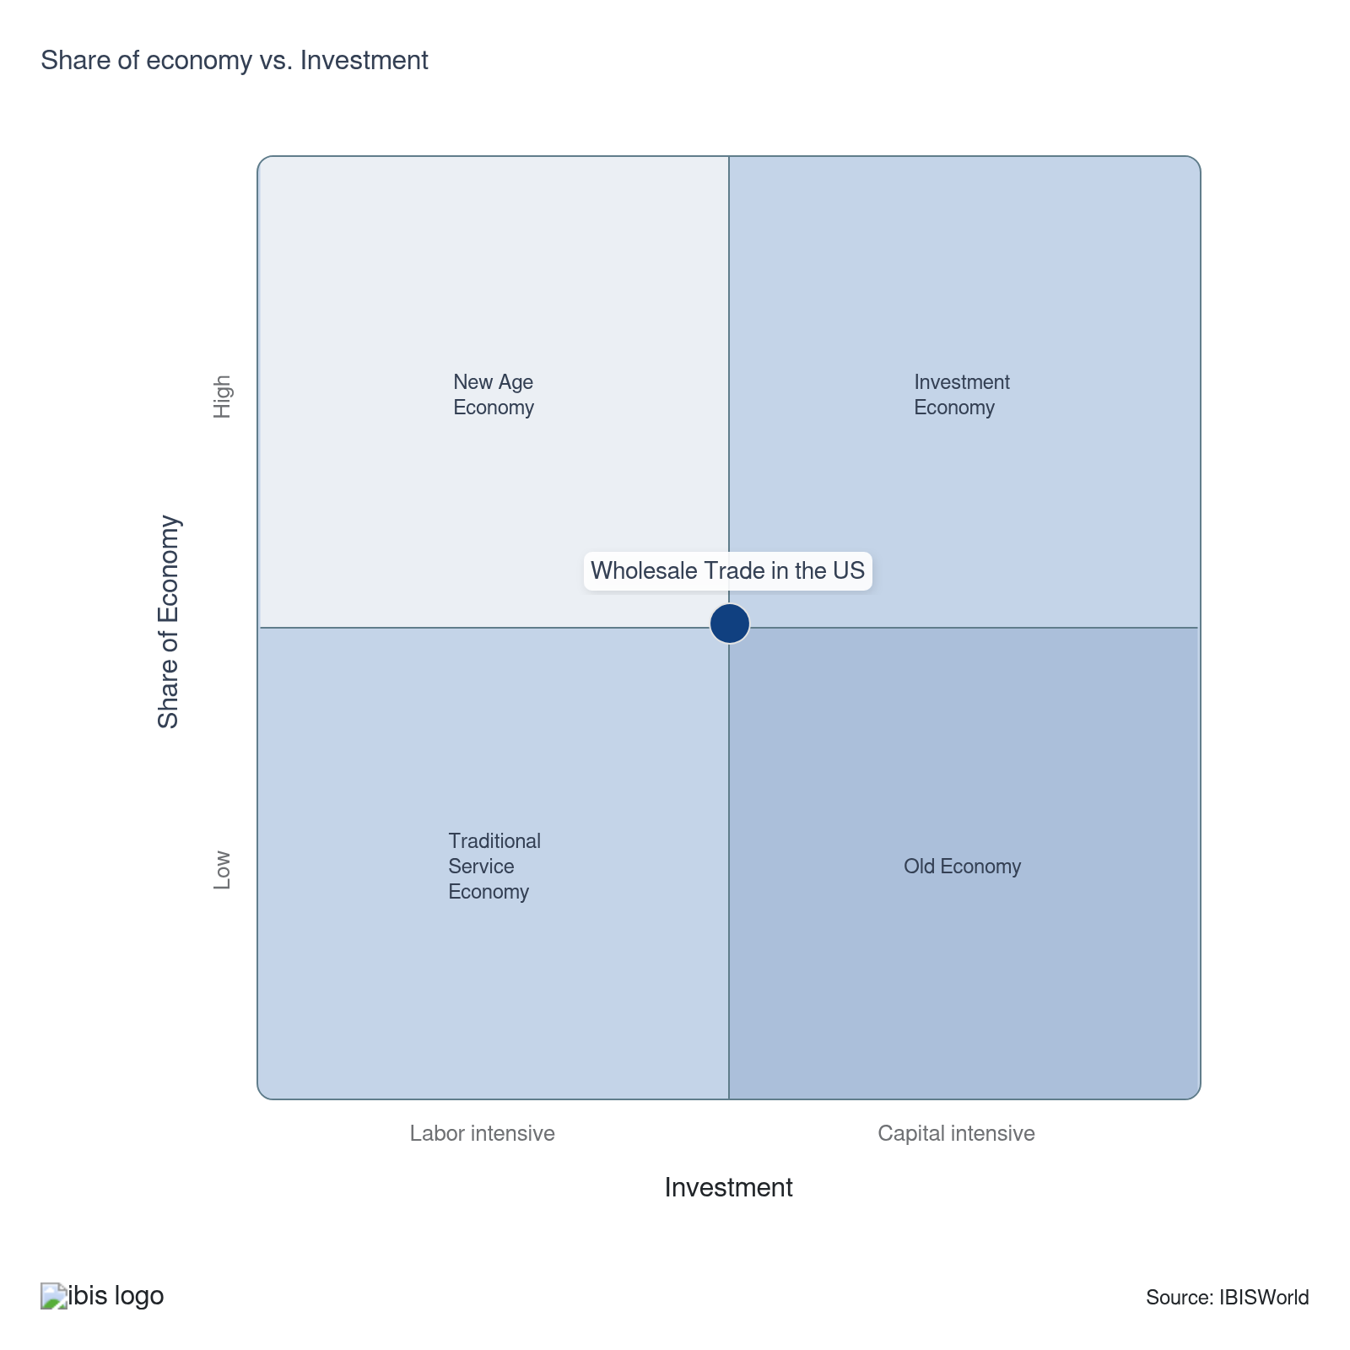

Key Ratios
Year | Revenue per Employee  ($) | Revenue per Enterprise  ($ Million) | Employees per Estab.  (Units) | Employees per Enterprise  (Units) | Average Wage  ($) | Wages/ Revenue  (%) | Estab. per Enterprise  (Units) | IVA/ Revenue  (%)
2005 | 1,344,584 | 11.9 | 7.8 | 8.8 | 78,236 | 5.8 | 1.1 | 9.3
2006 | 1,376,663 | 12.2 | 7.9 | 8.9 | 78,564 | 5.7 | 1.1 | 9.3
2007 | 1,428,268 | 12.3 | 7.6 | 8.6 | 78,214 | 5.5 | 1.1 | 9.4
2008 | 1,431,429 | 13.1 | 8.0 | 9.1 | 80,216 | 5.6 | 1.1 | 9.7
2009 | 1,276,225 | 11.2 | 7.7 | 8.8 | 79,574 | 6.2 | 1.1 | 10.2
2010 | 1,479,449 | 12.5 | 7.4 | 8.5 | 82,735 | 5.6 | 1.1 | 9.8
2011 | 1,628,677 | 13.8 | 7.4 | 8.5 | 84,828 | 5.2 | 1.1 | 8.8
2012 | 1,659,988 | 14.2 | 7.5 | 8.5 | 84,117 | 5.1 | 1.1 | 9.5
2013 | 1,658,766 | 14.6 | 7.6 | 8.8 | 84,535 | 5.1 | 1.1 | 9.6
2014 | 1,675,074 | 14.7 | 7.7 | 8.8 | 86,129 | 5.1 | 1.1 | 9.6
2015 | 1,562,244 | 14.0 | 7.8 | 9.0 | 87,708 | 5.6 | 1.1 | 10.3
2016 | 1,535,506 | 14.1 | 8.0 | 9.2 | 87,514 | 5.7 | 1.2 | 10.4
2017 | 1,614,357 | 15.1 | 8.1 | 9.3 | 87,292 | 5.4 | 1.2 | 10.2
2018 | 1,682,816 | 15.9 | 8.2 | 9.5 | 87,827 | 5.2 | 1.2 | 10.2
2019 | 1,649,377 | 16.0 | 8.3 | 9.7 | 88,927 | 5.4 | 1.2 | 10.3
2020 | 1,528,625 | 14.8 | 8.3 | 9.7 | 88,293 | 5.8 | 1.2 | 10.5
2021 | 1,824,078 | 17.2 | 8.1 | 9.5 | 93,666 | 5.1 | 1.2 | 10.4
2022 | 1,917,892 | 17.5 | 7.9 | 9.1 | 90,179 | 4.7 | 1.2 | 10.4
2023 | 1,670,837 | 15.4 | 8.0 | 9.2 | 90,310 | 5.4 | 1.2 | 10.4
2024 | 1,666,732 | 15.3 | 7.9 | 9.2 | 90,268 | 5.4 | 1.2 | 10.4
2025 | 1,679,086 | 15.5 | 8.0 | 9.2 | 90,402 | 5.4 | 1.2 | 10.4
2026 | 1,683,207 | 15.5 | 8.0 | 9.2 | 90,444 | 5.4 | 1.2 | 10.4
2027 | 1,692,121 | 15.7 | 8.0 | 9.3 | 90,540 | 5.4 | 1.2 | 10.4
2028 | 1,699,083 | 15.8 | 8.0 | 9.3 | 90,614 | 5.3 | 1.2 | 10.4
2029 | 1,700,531 | 15.8 | 8.0 | 9.3 | 90,630 | 5.3 | 1.2 | 10.4
2030 | 1,704,852 | 15.9 | 8.1 | 9.3 | 90,676 | 5.3 | 1.2 | 10.4
2031 | 1,709,650 | 16.0 | 8.1 | 9.3 | 90,727 | 5.3 | 1.2 | 10.4
2032 | 1,706,578 | 15.9 | 8.1 | 9.3 | 90,694 | 5.3 | 1.2 | 10.4
*Figures are inflation adjusted to 2026
*Figures are inflation adjusted to 2026

10. Key Statistics
https://my.ibisworld.com/us/en/industry/42/key-statistics

Industry Data

Values
Year | Revenue  ($ Million) | IVA  ($ Million) | Estab.  (Units) | Enterprises  (Units) | Employment  (Units) | Wages  ($ Million)
2005 | 8,538,197.3 | 794,958.1 | 810,960 | 717,873 | 6,350,066 | 496,806.6
2006 | 8,834,969.3 | 822,253.9 | 816,974 | 721,619 | 6,417,669 | 504,195.0
2007 | 9,093,370.8 | 852,607.6 | 836,327 | 736,539 | 6,366,713 | 497,966.2
2008 | 9,380,872.7 | 910,309.4 | 817,761 | 717,082 | 6,553,502 | 525,693.7
2009 | 7,935,435.3 | 812,200.4 | 809,884 | 709,080 | 6,217,895 | 494,783.1
2010 | 8,864,733.1 | 868,059.9 | 808,016 | 707,408 | 5,991,915 | 495,741.1
2011 | 9,820,304.8 | 865,014.5 | 815,222 | 712,438 | 6,029,620 | 511,483.6
2012 | 10,266,579.4 | 971,972.2 | 828,988 | 723,518 | 6,184,730 | 520,242.7
2013 | 10,475,490.9 | 1,005,257.3 | 826,117 | 719,009 | 6,315,232 | 533,860.1
2014 | 10,692,913.1 | 1,030,990.0 | 833,392 | 726,637 | 6,383,546 | 549,808.9
2015 | 10,144,242.8 | 1,046,303.3 | 830,709 | 724,331 | 6,493,381 | 569,523.9
2016 | 10,007,946.4 | 1,040,763.9 | 819,464 | 710,093 | 6,517,686 | 570,390.4
2017 | 10,517,108.2 | 1,074,930.8 | 808,917 | 697,388 | 6,514,737 | 568,686.8
2018 | 11,044,682.1 | 1,130,152.9 | 803,048 | 693,377 | 6,563,215 | 576,424.6
2019 | 10,841,178.3 | 1,117,195.4 | 789,035 | 679,055 | 6,572,894 | 584,511.0
2020 | 9,995,770.6 | 1,050,591.7 | 784,796 | 675,355 | 6,539,060 | 577,355.1
2021 | 11,515,603.7 | 1,197,519.2 | 778,007 | 667,741 | 6,313,110 | 591,321.0
2022 | 12,637,273.4 | 1,314,549.2 | 834,625 | 723,851 | 6,589,149 | 594,202.6
2023 | 11,185,960.1 | 1,168,227.9 | 840,547 | 728,508 | 6,694,823 | 604,611.3
2024 | 11,144,932.0 | 1,164,199.5 | 841,341 | 729,434 | 6,686,696 | 603,594.5
2025 | 11,461,030.8 | 1,196,366.5 | 853,919 | 739,755 | 6,825,757 | 617,063.8
2026 | 11,632,420.5 | 1,213,799.1 | 863,744 | 748,139 | 6,910,869 | 625,047.8
2027 | 11,941,248.9 | 1,245,298.3 | 879,820 | 761,745 | 7,056,970 | 638,937.8
2028 | 12,256,770.0 | 1,278,171.9 | 897,960 | 777,230 | 7,213,756 | 653,670.6
2029 | 12,534,251.9 | 1,307,203.8 | 917,367 | 794,078 | 7,370,785 | 668,013.6
2030 | 12,826,561.1 | 1,337,437.9 | 933,421 | 807,644 | 7,523,561 | 682,206.2
2031 | 13,149,574.8 | 1,370,838.7 | 951,284 | 822,754 | 7,691,382 | 697,816.1
2032 | 13,327,935.0 | 1,389,537.0 | 966,550 | 836,066 | 7,809,743 | 708,300.0

*Figures are inflation adjusted to 2026

Annual Change
Year | Revenue  % | IVA  % | Estab.  % | Enterprises  % | Employment  % | Wages  %
2005 | N/A | N/A | N/A | N/A | N/A | N/A
2006 | 3.5 | 3.4 | 0.7 | 0.5 | 1.1 | 1.5
2007 | 2.9 | 3.7 | 2.4 | 2.1 | -0.8 | -1.2
2008 | 3.2 | 6.8 | -2.2 | -2.6 | 2.9 | 5.6
2009 | -15.4 | -10.8 | -1.0 | -1.1 | -5.1 | -5.9
2010 | 11.7 | 6.9 | -0.2 | -0.2 | -3.6 | 0.2
2011 | 10.8 | -0.4 | 0.9 | 0.7 | 0.6 | 3.2
2012 | 4.5 | 12.4 | 1.7 | 1.6 | 2.6 | 1.7
2013 | 2.0 | 3.4 | -0.3 | -0.6 | 2.1 | 2.6
2014 | 2.1 | 2.6 | 0.9 | 1.1 | 1.1 | 3.0
2015 | -5.1 | 1.5 | -0.3 | -0.3 | 1.7 | 3.6
2016 | -1.3 | -0.5 | -1.4 | -2.0 | 0.4 | 0.2
2017 | 5.1 | 3.3 | -1.3 | -1.8 | 0.0 | -0.3
2018 | 5.0 | 5.1 | -0.7 | -0.6 | 0.7 | 1.4
2019 | -1.8 | -1.1 | -1.7 | -2.1 | 0.1 | 1.4
2020 | -7.8 | -6.0 | -0.5 | -0.5 | -0.5 | -1.2
2021 | 15.2 | 14.0 | -0.9 | -1.1 | -3.5 | 2.4
2022 | 9.7 | 9.8 | 7.3 | 8.4 | 4.4 | 0.5
2023 | -11.5 | -11.1 | 0.7 | 0.6 | 1.6 | 1.8
2024 | -0.4 | -0.3 | 0.1 | 0.1 | -0.1 | -0.2
2025 | 2.8 | 2.8 | 1.5 | 1.4 | 2.1 | 2.2
2026 | 1.5 | 1.5 | 1.2 | 1.1 | 1.2 | 1.3
2027 | 2.7 | 2.6 | 1.9 | 1.8 | 2.1 | 2.2
2028 | 2.6 | 2.6 | 2.1 | 2.0 | 2.2 | 2.3
2029 | 2.3 | 2.3 | 2.2 | 2.2 | 2.2 | 2.2
2030 | 2.3 | 2.3 | 1.8 | 1.7 | 2.1 | 2.1
2031 | 2.5 | 2.5 | 1.9 | 1.9 | 2.2 | 2.3
2032 | 1.4 | 1.4 | 1.6 | 1.6 | 1.5 | 1.5

*Figures are inflation adjusted to 2026

DISCLAIMER
This product has been supplied by IBISWorld Inc. (‘IBISWorld’) solely for use by its authorized licenses strictly in accordance with their license agreements with IBISWorld. IBISWorld makes no representation to any other person with regard to the completeness or accuracy of the data or information contained herein, and it accepts no responsibility and disclaims all liability (save for liability which cannot be lawfully disclaimed) for loss or damage whatsoever suffered or incurred by any other person resulting from the use of, or reliance upon, the data or information contained herein. Copyright in this publication is owned by IBISWorld Inc. The publication is sold on the basis that the purchaser agrees not to copy the material contained within it for other than the purchasers own purposes. In the event that the purchaser uses or quotes from the material in this publication – in papers, reports, or opinions prepared for any other person – it is agreed that it will be sourced to: IBISWorld Inc.

